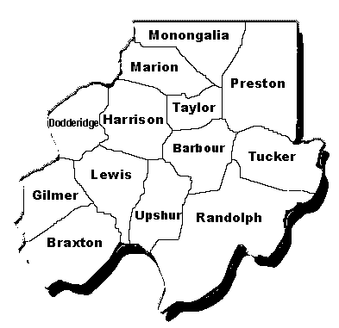

NOMINATION FORM

Region VI Workforce Investment Board

Please send a copy to: Region VI Workforce Investment Board, 17 Middletown Rd, White Hall WV 26554

Name (First, MI, Last) |  | Local Workforce Investment Area  Region VI |  |  | Date
Street Address |  |  |  | Recommended for (see section)  a. Community Based Org. (CBO) ____  b. Private Sector (Business) ____  c. Education ____  d. Economic Development ____  e. Organized Labor ____  f. One-Stop Partner ____  Other ____
City | County
State | ZIP
Home Phone (include area code) | Work Phone (include area code)
FAX | E-Mail |  |  | Nomination  - New  - Reappointment

Physical Location of Organization
a. CBO Representative  Title ______________________________________  Organization ___________________________________ |  |  | b. Private Sector (Business) Representative  Title ________________________________________  Business _____________________________________  Type of Business ____________________________
c. Education Representative  Title ____________________________________________  Institution _______________________________________  Local Ed. _____ Post Secondary _____ Voc Ed. _____ |  |  | e. Organized Labor Representative  (Please Specify local labor council or building and trades council of affiliation)  _________________________________________________
d. Economic Development Representative  Title ____________________________________________ |  |  | f. One-Stop Partner Representative  Title _____________________________________________  Agency/Entity _____________________________________
Nominator  I hereby recommend the above named person for membership on the Local Workforce Investment Board for Region VI service area.  __________________________________________________  Signature Date  __________________________________________________  Printed/Typed Name & Title of Nominator  Marion County Chamber of Commerce  ______________________________________________________________  Nominator Organization  ______________________________________________________________  Phone FAX  ______________________________________________________________  E-Mail |  |  | Action by Local Elected Official  Subject to certification required by Section 117 of the Workforce Investment Act of 1998, the person nominated herein has been duly appointed to the Local Workforce Investment Board by the Chief Elected Officials of Region VI.  Term of Appointment: FROM __________ TO __________  __________________________________________________  Signature of Chief Local Elected Official Date

Certification of Local Elected Official Chair

__________________________________________________
Signature of Chair Date

