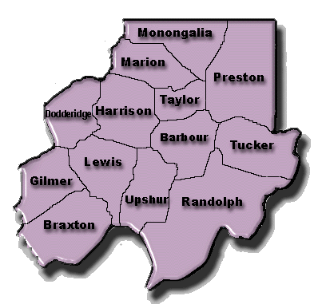

# **NOMINATION FORM**

## Region VI Workforce Investment Board



Please send a copy to: Region VI Workforce Investment Board, 109 Adams St. Suite 140, Fairmont WV 26554

|  |  |  |  |  |  |
| --- | --- | --- | --- | --- | --- |
| **Name (*First, MI, Last)***  **Pratt, Judy R.** | | **Local Workforce Investment Area**  Region VI | | | **Date** |
| **Street Address**  **1000 Mississippi St.** | | | | **Recommended for** *(see section)*  a. Community Based Org. (CBO) ____  b. Private Sector (Business) ____  c. Education _X__  d. Economic Development ____  e. Organized Labor ____  f. One-Stop Partner ____  Other ____ | |
| **City**  **Morgantown** | **County**  **Monongalia** | | |
| **State**  **WV** | **ZIP**  **26501** | | |
| **Home Phone (*include area code)*** | **Work Phone (*include area code)***  **304-291-9240** | | |
| **FAX**  **304-291-9247** | **E-Mail**  **jrpratt@access.k12.wv.us** | | | Nomination  * New   X Reappointment | |
| Physical Location of Organization Morgantown, WV | | | |
| **a. CBO Representative**  Title ______________________________________  Organization ___________________________________ | | | **b. Private Sector (Business) Representative**    Title ________________________________________  Business _____________________________________  Type of Business ____________________________ | | |
| **c. Education Representative**    Title ___Business and Industry Coordinator_____________  Institution __Monongalia County Schools______________  Local Ed. _____ Post Secondary _____ Voc Ed. _____ | | | **e. Organized Labor Representative**  (Please Specify local labor council or building and trades council of affiliation)  _________________________________________________ | | |
| **d. Economic Development Representative**    Title ____________________________________________ | | | **f. One-Stop Partner Representative**  Title _____________________________________________  Agency/Entity _____________________________________ | | |
| **Nominator**  *I hereby recommend the above named person for membership on the Local Workforce Investment Board for Region VI service area.*  __________________________________________________  Signature Date  __________________________________________________  Printed/Typed Name & Title of Nominator  Marion County Chamber of Commerce  ______________________________________________________________  Nominator Organization  ______________________________________________________________  Phone FAX  ______________________________________________________________  E-Mail | | | **Action by Local Elected Official**  Subject to certification required by Section 117 of the Workforce Investment Act of 1998, the person nominated herein has been duly appointed to the Local Workforce Investment Board by the Chief Elected Officials of Region VI.  Term of Appointment: FROM __________ TO __________  __________________________________________________  Signature of Chief Local Elected Official Date | | |
| Certification of Local Elected Official Chair __________________________________________________  Signature of Chair Date | | |