# Pulling Inventory for use on Buses

An overview of the steps involved in pulling parts from inventory for use on buses is as follows:

1. Start Memo Pad on the PDA.
2. Examine current memos to find the bus needing parts. If one exists, open it, skip to step 5.
3. If no current memos exist for that bus, create a new memo.
4. In creating a new memo, enter the word “bus” and the number of the bus to the first line. (the first line MUST be the bus number so memos are properly titled)
5. On the next available line, use the code scanner function to scan in the part to be used. (Be sure to scan only the MLTA barcode tag and not a manufacturers or shipping tag.)
6. On the next line type the letter “Q” and the quantity to be removed from inventory.
7. Go back to step 5 and repeat as many times as is needed to include all parts to be used on that bus. Once all parts for that bus have been added to the memo, press DONE on the PDA screen to save those items.

The above overview is described in more detail below.

1. From the main screen on the PDA, tap the Memo Pad icon.

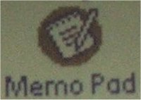

1. When Memo Pad open, you be presented with a list of all current memos (as shown below). Examine the list for a memo on the current bus. If one exists, tap it to open it for additions and skip to step 5.

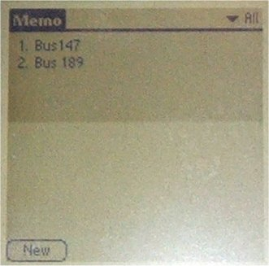

1. If no existing memo exists for the current bus, create a new memo by tapping “New” at the bottom left corner of the screen. (shown above)
2. In creating a new memo, enter the word “bus” and the number of the bus to the first line. (the first line MUST be the bus number so memos are properly titled as shown below)



1. On the next available line, use the code scanner function to scan in the part to be used. (Be sure to scan only the MLTA barcode tag and not a manufacturers or shipping tag.)



1. On the next line type the letter “Q” and the quantity to be removed from inventory.



1. Go back to step 5 and repeat as many times as is needed to include all parts to be used on that bus. Once all parts for that bus have been added to the memo, press DONE on the PDA screen to save those items.
2. Deliver the PDA to the office for data import.