# PDA Walkthrough

There is a pointer or “stylus” located in the top right corner of the PDA. It is used to tap/touch different items on the PDA screen to interact with the device.

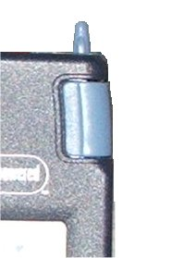

The blue button located at the bottom left edge is to power the PDA on. The following image is of the main screen of the PDA, the power button is visible in the lower left corner.

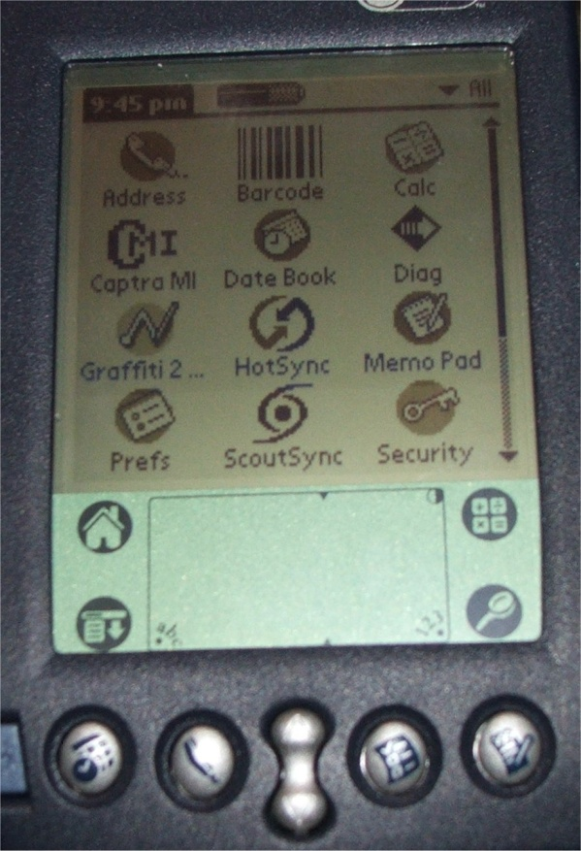

Make note of the picture of the house at the left side of the lower panel of the screen, at any time you get lost you can touch it with the pointer and return to the main screen.

At the top of the PDA there are two blue buttons on both the right and left edges, these are shown in the following image and used to activate the bar code scanner function. NOTE: While in Captra, please do not scan items not already in the QuickBooks database and assigned MLTA part numbers. You may scan other bar codes while in Memo Pad (to enter manufacturer’s part numbers, etc; mentioned later)

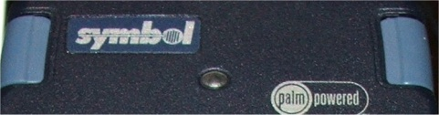

When text or numbers need to be entered, use the pointer to touch below the screen near the bottom where you see “abc” or “123”. The screens are shown below.

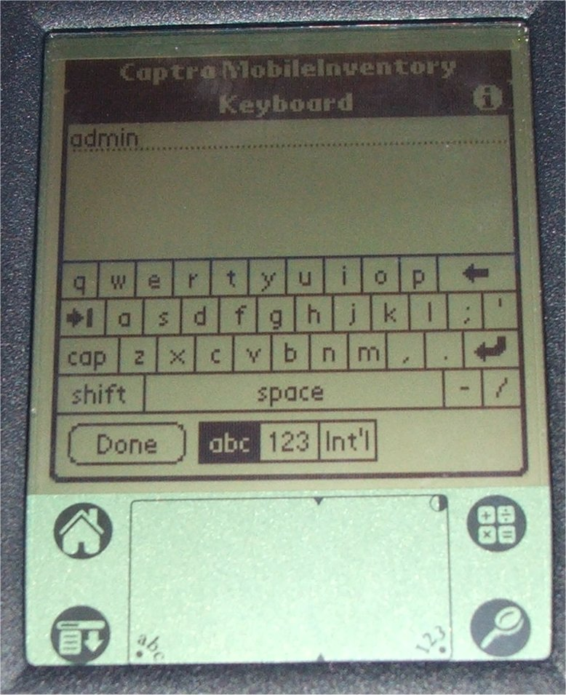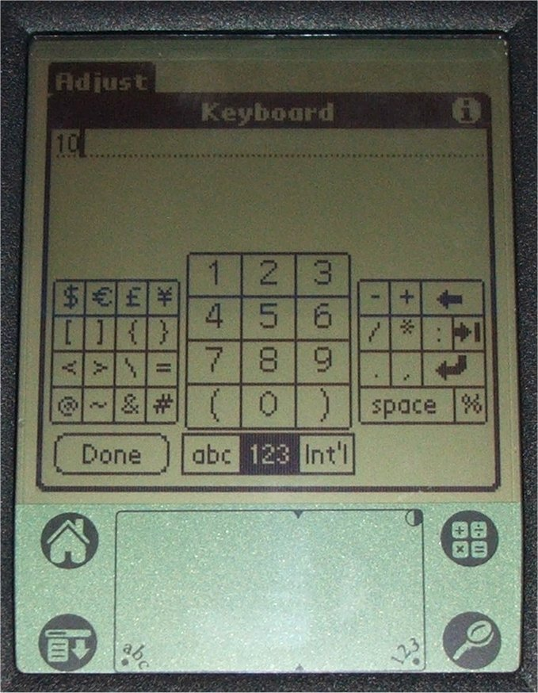

Make note on the right of both screens, there are two arrows pointing left, the top one that points straight left is backspace (to correct typos) and the one that points down and to the left is the “line return” or “enter”.

The button used to perform the “hot sync” procedure is located on the base unit of the PDA and the PDA must be securely seated in the base to perform a hot sync. The button on your unit is broken; I advise using the pointer for the PDA to gently press the button. Shown below, you must press directly in the center (on the white part).

