# Mountain Line Transit Authority

Inventory Database Overview and Procedures

These instructions are based on QuickBooks 2008 and Symbol Captra MobileInventory v1 and have been prepared by Layman’s PC Sales and Service.

These instructions are not intended to provide full information about the system, only as an overview of steps needed to manage inventory flow. There are may be additional functions of the system that can be implemented and these documents may be revised at any time. The following instructions are broken up into the following parts; Summary of the Captra MobileInventory Data Cycle, Enter Data in QuickBooks, PDA Walkthrough, Starting Captra on PDA, Adding New Items (with Memo Pad), Adjusting Item Quantities, Receiving Items, Pulling Items for Use, Definitions of terms.

# Summary of the inventory Data Cycle:

The following is an overview of the dataflow throughout the system’s day to day use and further explanations of each step are summarized below. Enter data (such as invoices and purchase orders) into Quickbooks (1), Transfer data to Captra MI (2), Perform PC to PDA HotSync (3), Use the PDA to ”Pick” inventory for use on pending invoices or “receive” pending purchase orders with the PDA (4), Perform PDA to PC HotSync (5), Processing Mobile Data takes the data from the HotSync and compiles it for use in the Captra database (6), and next is a two part step(7). Receive transactions from the PDA must be printed and manually entered into QuickBooks (A), Parts that are pulled from inventory for use (Picked) you will use the “Commit Pick Tickets to QuickBooks” procedure to add the changes to QuickBooks automatically..

1. Initially, the “Enter Data in QuickBooks” step encompasses the QuickBooks data entry required to define the following data:  **Inventory Part Items**, **Customers**, **Vendors**, **Purchase Orders, Credit Memos**, and **Pending Invoices**.  After completing each data cycle, as shown above, this will include the entry of printed Item Receipts (generated by Captra MobileInventory) for Items Received against QuickBooks Purchase Orders/Credit Memos.  After entering data in QuickBooks, this is also where one should run Compare Inventories to identify and reconcile any item quantity discrepancies between the two databases.
2. “Transfer Data from QuickBooks” transfers Inventory Part Items, Customers, Vendors, Purchase Orders, Credit Memos and Pending Invoices from QuickBooks to the Captra MobileInventory database.  Sites and Locations are assigned to new Items and Serial Numbers are recorded, if desired.
3. PC to PDA transfers the Captra MobileInventory database to the PDA when a HotSync is initiated at the PDA.
4. The PDA can now be used to Pick items for shipping against Pick Tickets (Pending Invoices) and/or Receive items against QuickBooks Purchase Orders / Credit Memos. Move, Adjust, Details and Audit inventory transactions can also be performed on the PDA, as well as Review Pick and Review Receive functions.
5. PDA to PC readies the PC to receive mobile transactions from the PDA.  A HotSync initiated at the PDA then transfers all the PDA transactions to the PC along with any new inventory Locations or Item Serial Numbers the PDA User has recorded.
6. Process Mobile Device Data allows you to validate transactions recently received from one or more PDA's, accepting them into Captra MobileInventory's PC database.

A. If one or more Receive transactions were performed, on the PDA or on the PC, Print Item Receipts for QuickBooks Data Entry generates receipts that will be manually entered in QuickBooks for Items received against QuickBooks Purchase Orders or Credit Memos (in Step 1, above).

B. If one or more Pick transactions were performed, on the PDA or on the PC, Commit Pick Tickets to QuickBooks marks Pending Invoices as final and/or creates Backorders. Unlike the entry of Item Receipts, this does not require manual entry of data in QuickBooks.

# Enter Data to QuickBooks

# PDA Walkthrough

There is a pointer or “stylus” located in the top right corner of the PDA. It is used to touch different items on the PDA screen to interact with the device. The blue button located at the bottom left edge is to power the PDA on. The following image is of the main screen of the PDA, the power button is visible in the lower left corner.

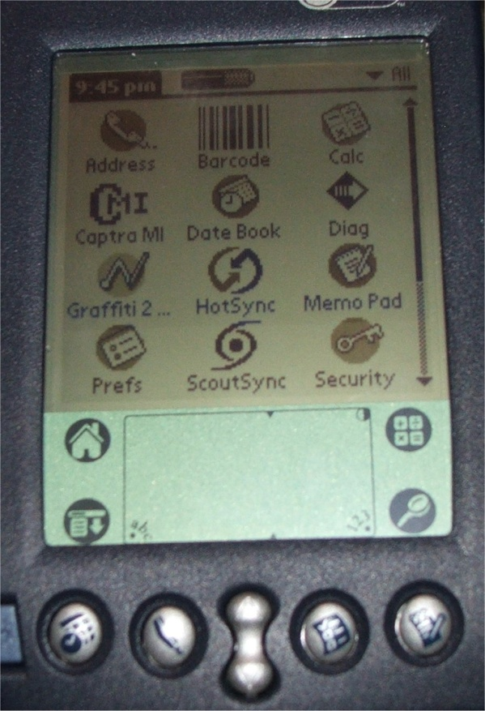

Make note of the picture of the house at the left side of the lower panel of the screen, at any time you get lost you can touch it with the pointer and return to the main screen.

At the top of the PDA there are two blue buttons on both the right and left edges, these are shown in the following image and used to activate the bar code scanner function. NOTE: While in Captra, please do not scan items not already in the QuickBooks database and assigned MLTA part numbers. You may scan other bar codes while in Memo Pad (to enter manufacturer’s part numbers, etc; mentioned later)

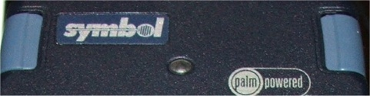

When text or numbers need to be entered, use the pointer to touch below the screen near the bottom where you see “abc” or “123”. The screens are shown below.

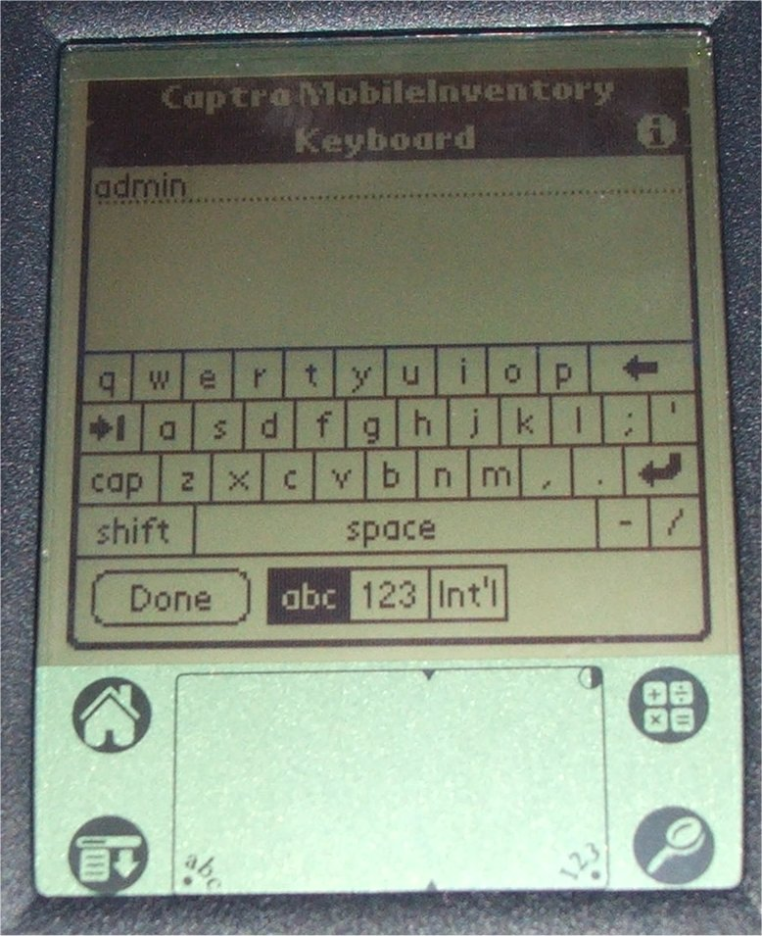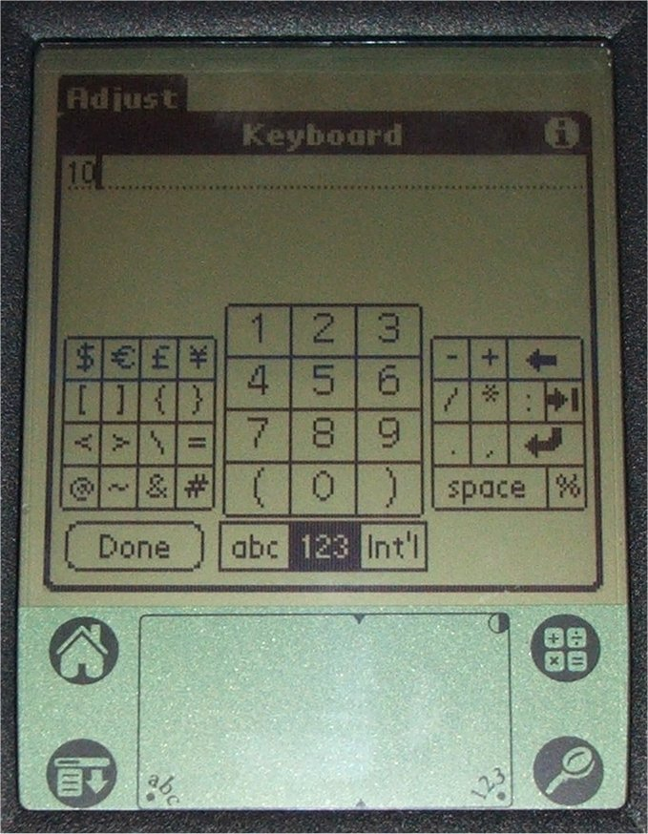

Make note on the right of both screens, there are two arrows pointing left, the top one that points straight left is backspace (to correct typos) and the one that points down and to the left is the “line return”.

The button used to perform the “hot sync” procedure is located on the base unit of the PDA and the PDA must be securely seated in the base to perform a hot sync. The button on your unit is broken; I advise using the pointer for the PDA to gently press the button. Shown below, you must press directly in the center (on the white part).

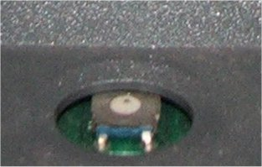

# Starting Captra on the PDA

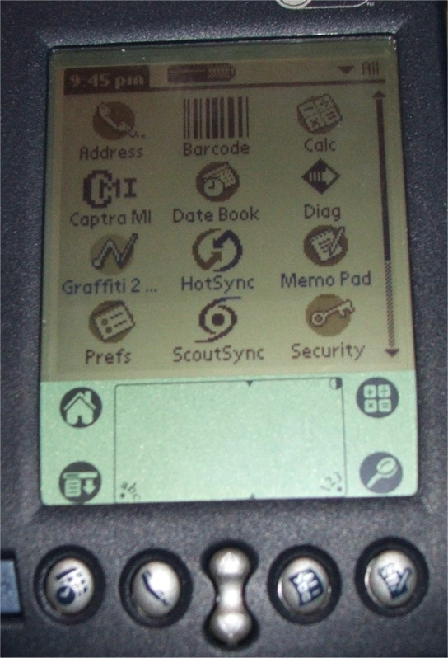

For ease I’ve setup a special screen in the PDA to only show the items needed for MLTA procedures. If the screen above is what you see, use the pointer and touch the screen at the far top right. There is a small arrow pointing down and the word “all” in the image above. A list will appear, choose MLTA from this list. You should see the following screens.

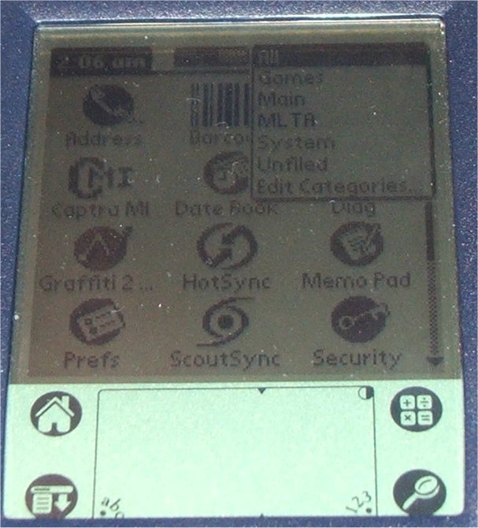 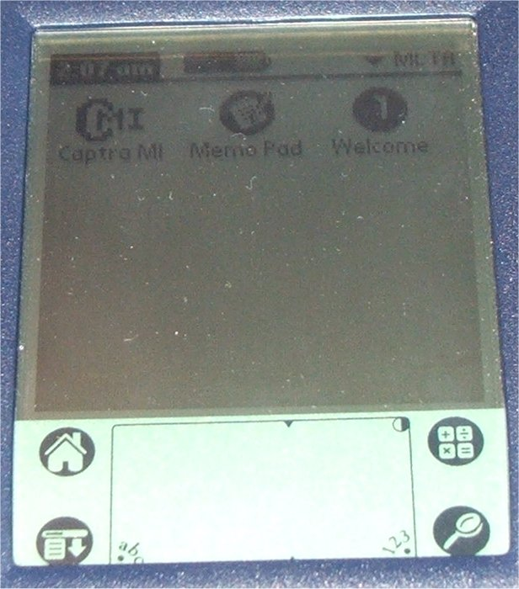

You can now start Captra by simply touching the icon labeled Captra MI. After several seconds the Captra software will load and you will be presented with the login screen (shown in the following image).

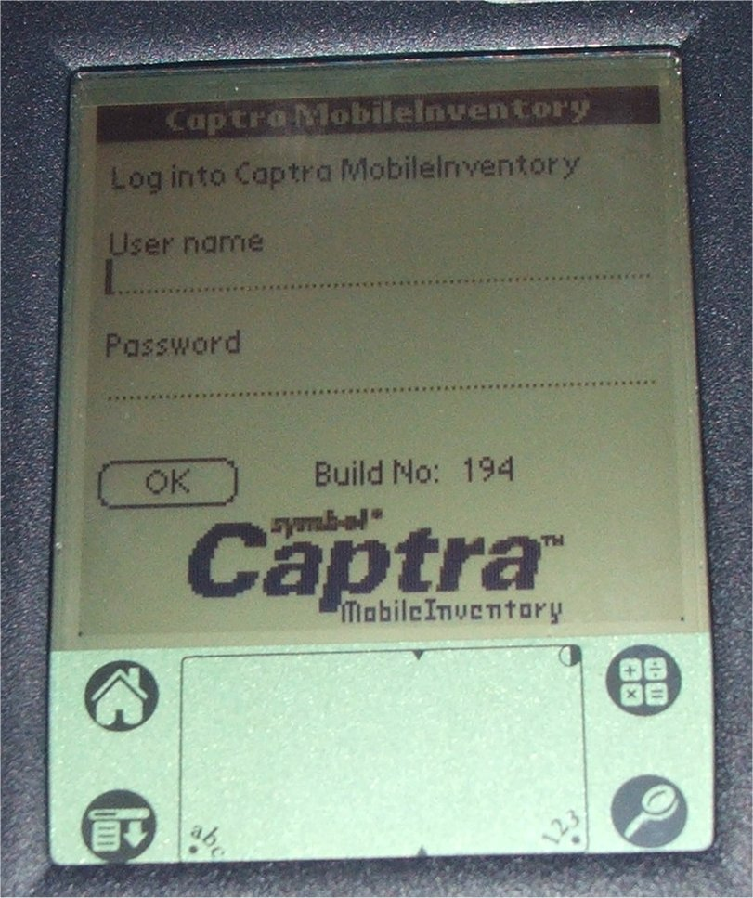

Here you use the pointer and tap where you wish to place text, start with the “User name” field. Next you will tap the “abc” below the screen shown in the lower left corner of the above image, this will bring up the keyboard screen.



Touch the letter on the onscreen keyboard with the pointer to enter your assigned username. Touch the lower left corner of the screen where it says “Done” when completed entering the username.

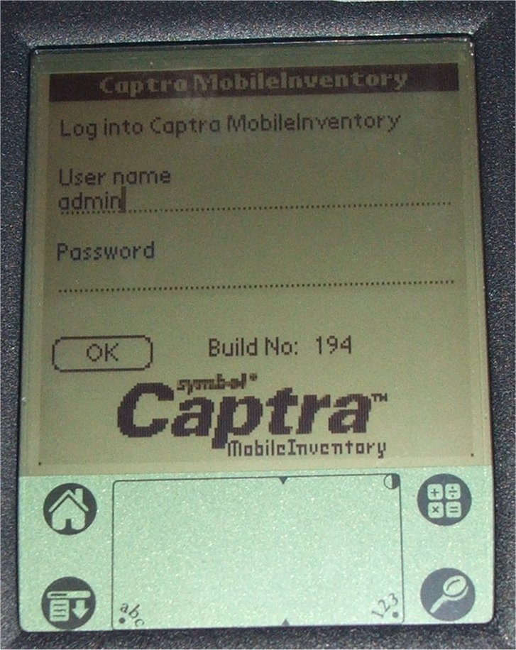

Shown above is the entered user name. Touch the line for “Password” to select it and touch “abc” at the bottom to access the onscreen keyboard again to enter your password. Once both the user name and password are entered, touch the screen (shown above) where it says “OK”. The main Captra screen (shown below) will appear.

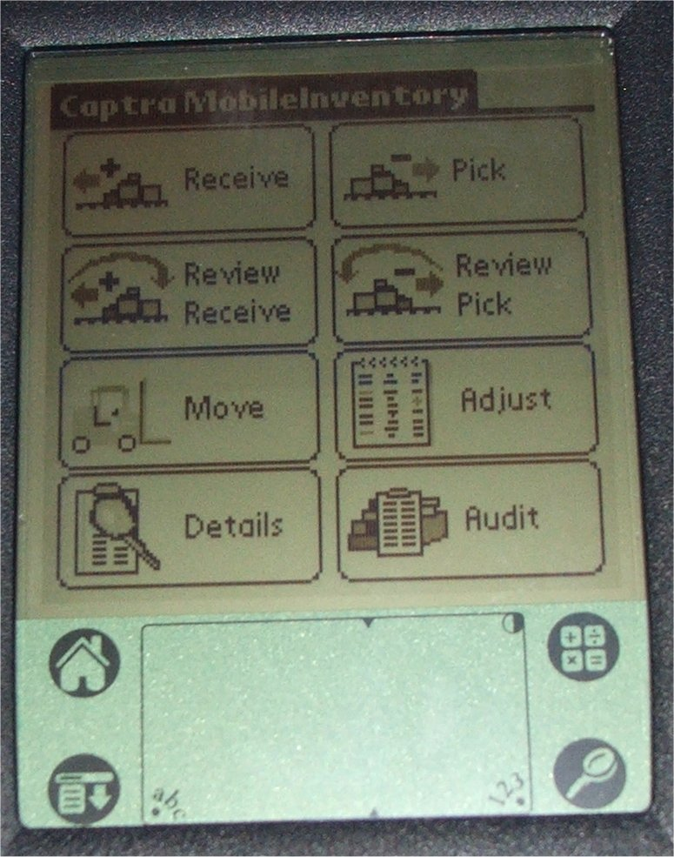

From here, all the main procedures will be started.

# Adding New Items

The following is the category assignments:

* 100—Hardware (this consists of general screws and miscellaneous hardware items and should

only be counted per container unless needs arise for more precise monitoring)

* 200—Chassis Electrical (this can include interior or exterior lighting , fuses, relays, radios and

GPS)

* 300—Chassis Mechanical Components (brakes, suspension, exhaust components, doors, windows,
* body panels, light housings)
* 400—Engine Electrical (sensors, switches, wiring, connectors, ignition components, alternators,

starters)

* 500—Engine Mechanical Components (items such as, turbo kits, A/C pumps, Water pumps)
* 600—Fuel System Components
* 700—Chemicals (i.e. Brake Parts Cleaner, antifreeze/coolant, WD-40, Car Wash Solution)
* 999—Category unknown or not listed

The final five digits of the item number will be added by the personnel who enter the data into QuickBooks and should be added in a sequential order starting 10000, 10001, 10002, 10003, etc.

Items that are “paired” items can be listed as “sub-categories” to what is shown above. As an example, headlight bulbs may be 20110035, the headlight high beam switch could be 20210035, the headlight on/off switch could be 20310035, or a special “specific-use” bolt could be 10110049 could have a corresponding nut 10210049. Fuel System Components category could be divided with 600—649 numbers being reserved for diesel parts and 650— 699 being used for gasoline parts. This truly should only be used in specific circumstances and will require either the garage personnel or a dedicated storeroom clerk to group the items.

Once adding extra vendors for identical parts (to have different price points set) the numbers will have “.01”, “.02”, etc. added to the end. i.e. 40010025 is an oxygen sensor from the primary vendor, 40010025.01 would be the same part from a secondary distributor).

# Adjusting Item Quantities

This procedure is used to do a physical inventory count in the store room and adjust QuickBooks to match.

Start Captra MI, choose adjust.



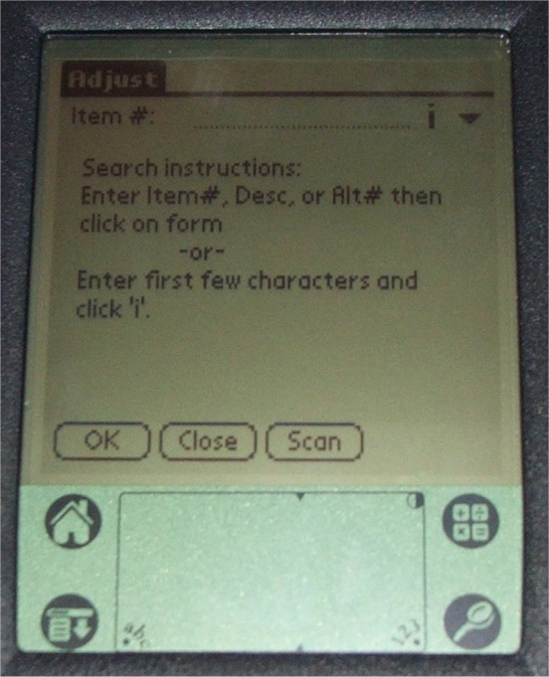

Here you will either touch the screen where it says “Scan” to activate the scanner for 5 seconds or press one of the blue scan buttons at the top corners and scan the item’s bar code. Please be sure you are scanning a current MLTA bar code. The following screen will appear.

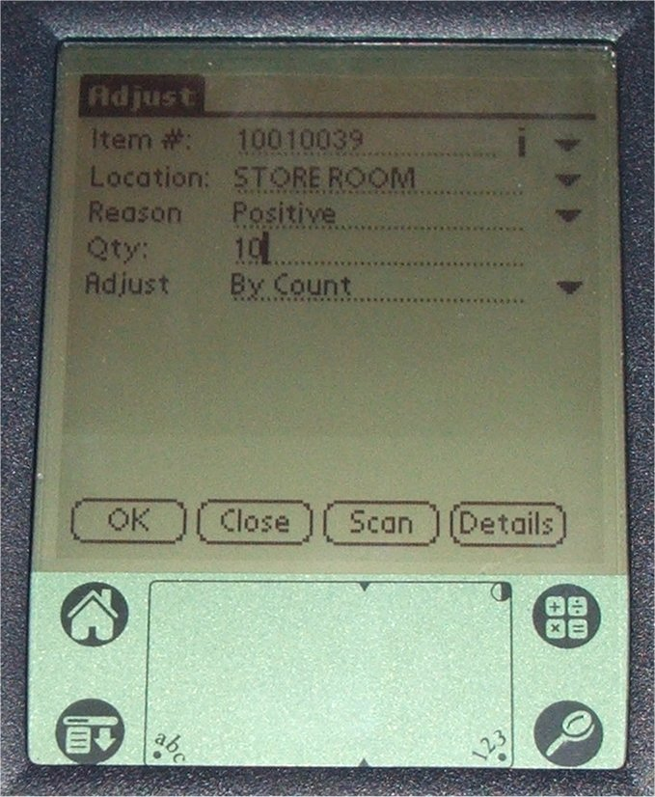

The breakdown of this screen is as follows:

The Item # field will be filled in by the number of the item scanned. You can touch the “down arrow” to the right of the Item # to change the view of this field to show the description of the item rather than the item number.

The Location field can be altered to match only locations added in the software. All shelf locations should be listed. To choose, touch the “down arrow” at the right side of this field and select from the list.

The Reason can be listed as Positive (used in performing physical inventory count; when inventory database indicates less than is on the shelf, Positive will be used), Negative (used in performing physical inventory count; when inventory database indicates there are more than is physically on the shelf, Negative will be used), Lost (an item is temporarily removed from the store room then misplaced, it must be removed from inventory), Found (when a previously lost item is found, this is used to add it back into inventory), Return (when an item is pulled from inventory and not used, Return should be chosen), or Breakage (in getting an item from stock and a broken part is noticed on the shelf, Breakage should be used). Use the “down arrow” at the right of that field to select whatever is appropriate.

The Qty field should reflect the number you personally count. Touch the “123” at the bottom and activate the onscreen number pad to enter the quantity.

The Adjust field works in conjunction with the Qty field to maintain proper item counts in the database. There are the following choices available for this field: By Count and By Difference. By Count is used when all of an item has been counted and you are entering the exact quantity on hand (already in inventory and not already in inventory). By Difference is used when you are only counting a specific number of an item that’s not already in inventory (i.e. you find a box of 15 of an item shoved under a bench and just want to add them to existing inventory).

Once all the fields are completed, you can touch the “OK” button on the lower left portion of the screen. It will make the change in the PDA database and clear the form for the next item. When completed with adjustments of all items, touch the “Close” button at the bottom of the screen. (NOTE: when completing inventory adjustments please only choose “Close” from a cleared screen after “OK” has been selected and the item adjusted.)

# Import quantity adjustments from the PDA into QuickBooks.

First insert the PDA into the cradle and start both, QuickBooks and Captra. In Captra, choose “Mobility” on the left at the bottom, and then choose “PDA to PC” from the right portion of the screen. You will see the following screens.

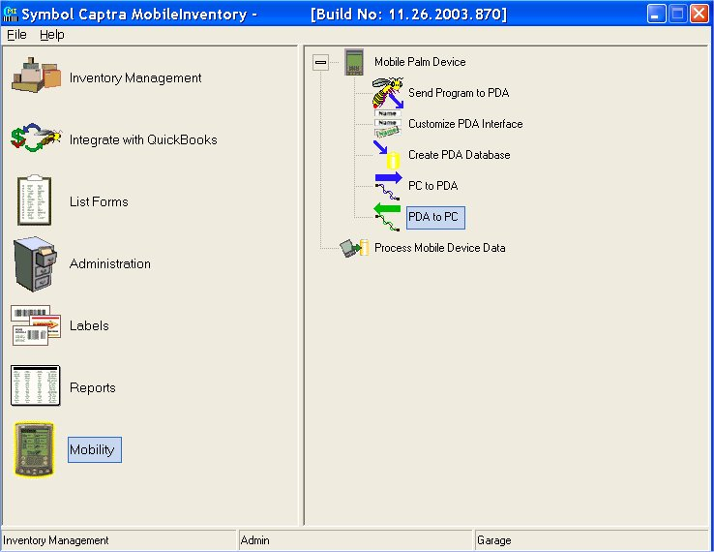

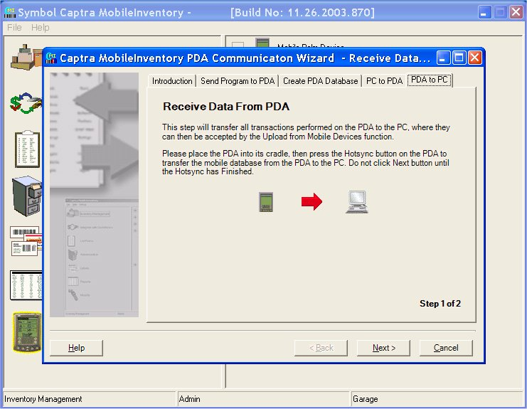

At this screen you will press the “Hot Sync” button on the PDA Cradle. (Shown below)



The system will begin the procedure of receiving the PDA quantity adjustments into the Captra MI software in the PC. After it completes the transfer, it will bring up the following screen, press “Finish”.

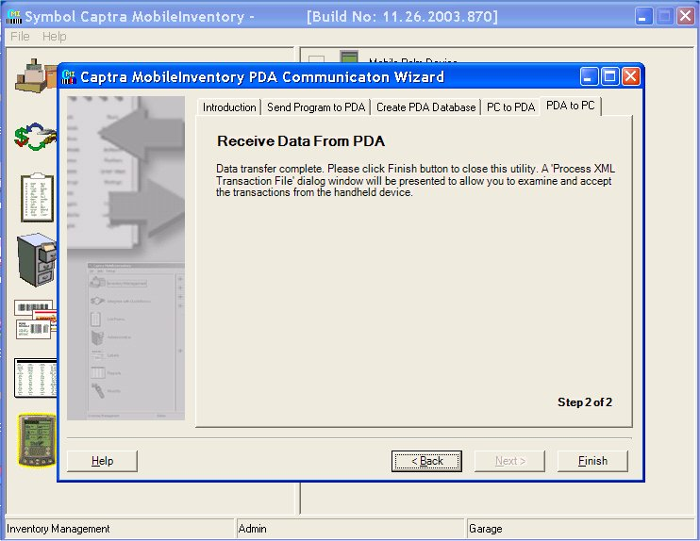

After pressing “Finish” (above) Captra will display the screen to upload changes into the Captra MI database. (Shown below)

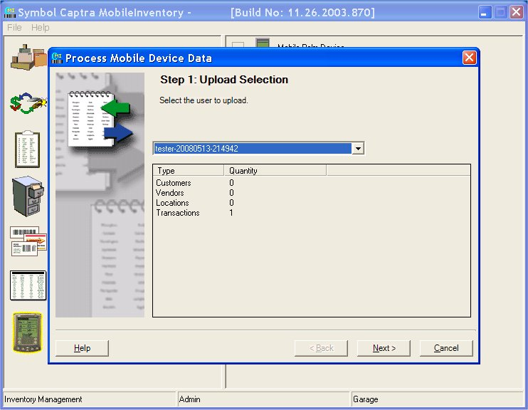

First you will be presented with the screen above. You will have a list of profiles containing dated changes in the selection drop down box. In most cases there should only be one to choose from as only changes that have not been properly imported will show up in this list. After selecting the set of changes you wish to import in the screen above, click “Next” to see the following screen.

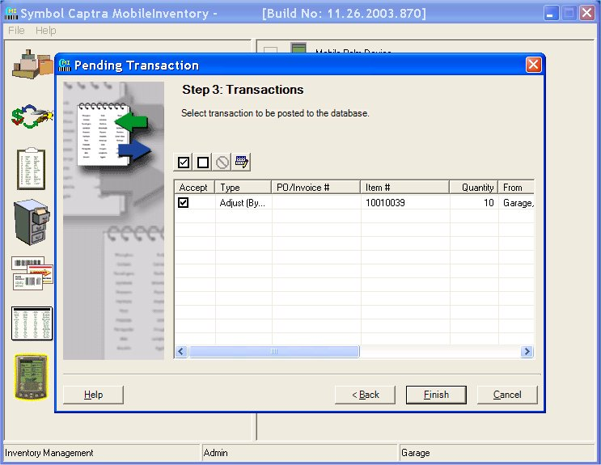

At this screen (shown above) you will have a list of changes that were made with the PDA to inventory items. Select them for import into the database by placing a check in the box to the left of each item. If there is an error with any item that prevents it from being imported it will be indicated by a red circle with a line through it. The four buttons just above the list can be used to get the details of the failure and make edits to the transactions so they can be imported. Once you have all transactions ready for import, press the “Finish” button at the bottom.

# Balancing Captra and QuickBooks item counts.

** NOTE ** For this part of the procedure you must have QuickBooks in “Single user mode”.

Starting in Captra MI, select “integrate with QuickBooks” on the left, and then “Compare Inventories” on the right. (As shown below)

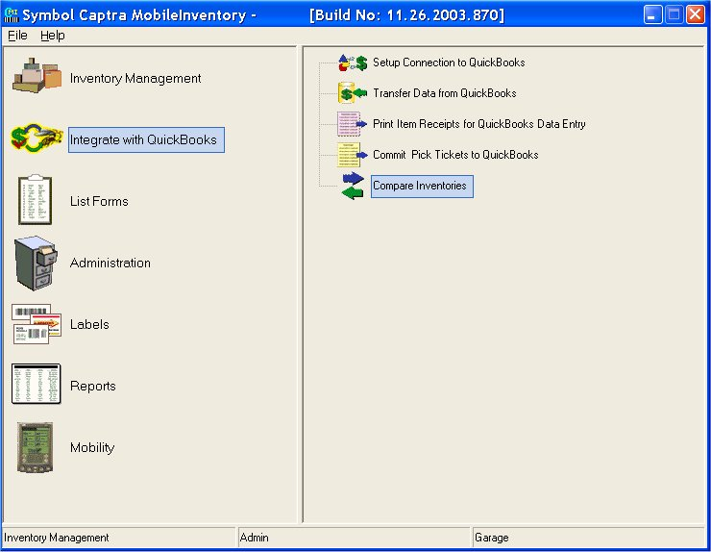

Step 1, shown below, you will simply click “Next”.

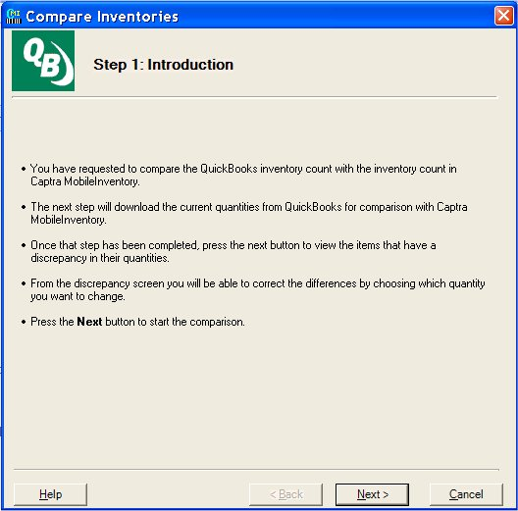

Pressing next will display the following screen. Here Captra will make connection to the QuickBooks database and analyze the data. (Shown below)

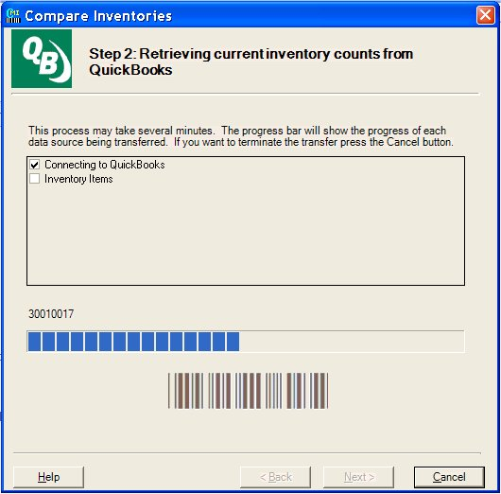

Once Captra is completed analyzing the QuickBooks inventory it will display a list of items that contain differing quantities. (Shown below)

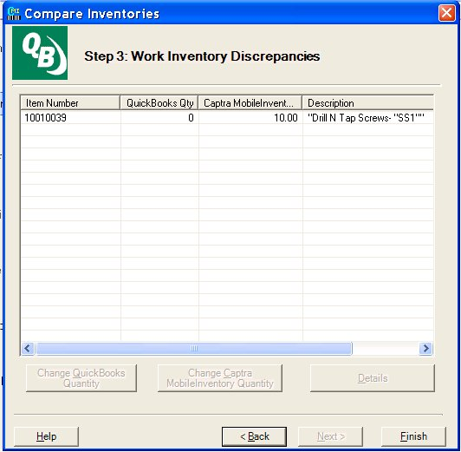

In the screen above you select the item or items that are different and the buttons at the bottom will become available for selection. (Shown below)

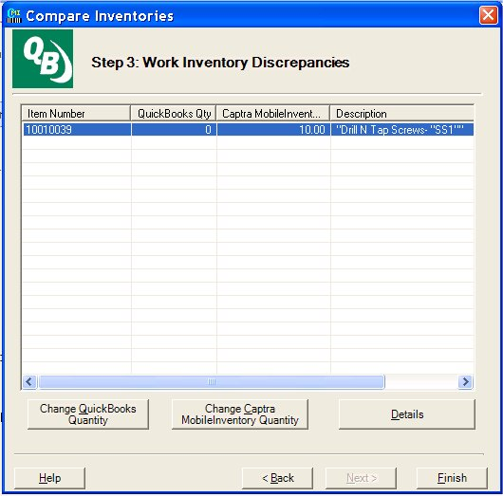

Selecting each item that needs adjusted; choose the “Change QuickBooks Quantity” button on the left. This will change the Quickbooks inventory to match the current Captra database.

# Create Memos to Request POs, New Item Additions, or Changes to Existing Inventory Items

To create a Memo with the PDA for needs not provided by the system, from the PDA main screen (shown below) choose “Memo Pad”.

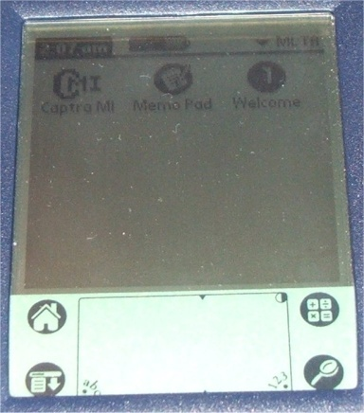

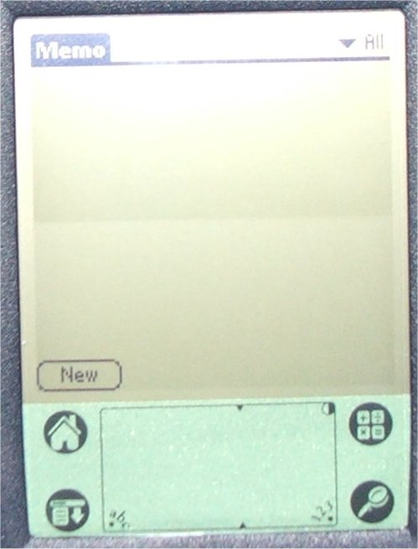

From this screen you will be able to see existing memos and add new memos. To add a new memo, touch the lower left corner on the text “New”. At this point you will touch the “123” and “abc” to enable the onscreen keyboard and number pad and enter the relevant data. For a new inventory item, choose an item group for the new part from the item number prefixes listed at the beginning of this section, a detailed description for the part, the vendor it is purchased through, and the manufacturer’s part number (MPN). Use line return (the arrow that points down and left on the right side of the screen to move down from line to line. Data such as the Manufacturer’s Part Number can be scanned by the bar code scanner (only on items that have the part number bar-coded on their packaging) by pressing either of the two scan buttons at the top on the sides. This can also be used to scan MLTA labels for requesting edits to the descriptions in the database, or requesting Purchase Orders, etc..

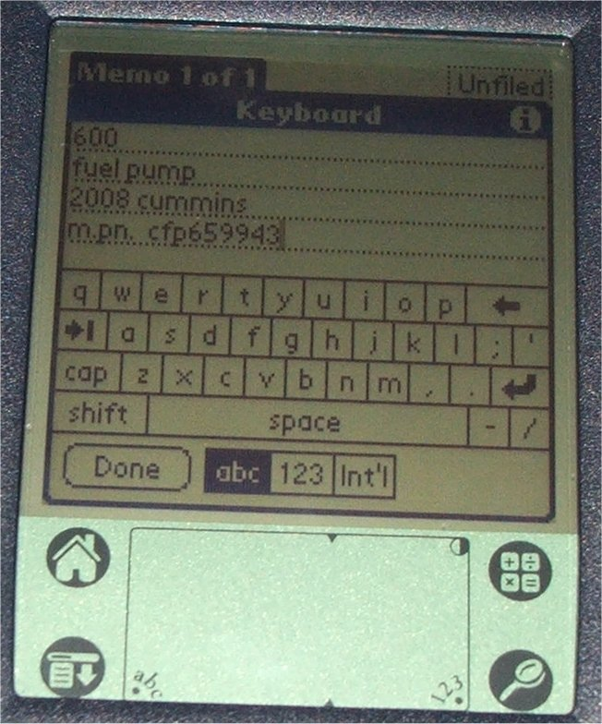

When complete, touch the “Done” button at the bottom of the screen.

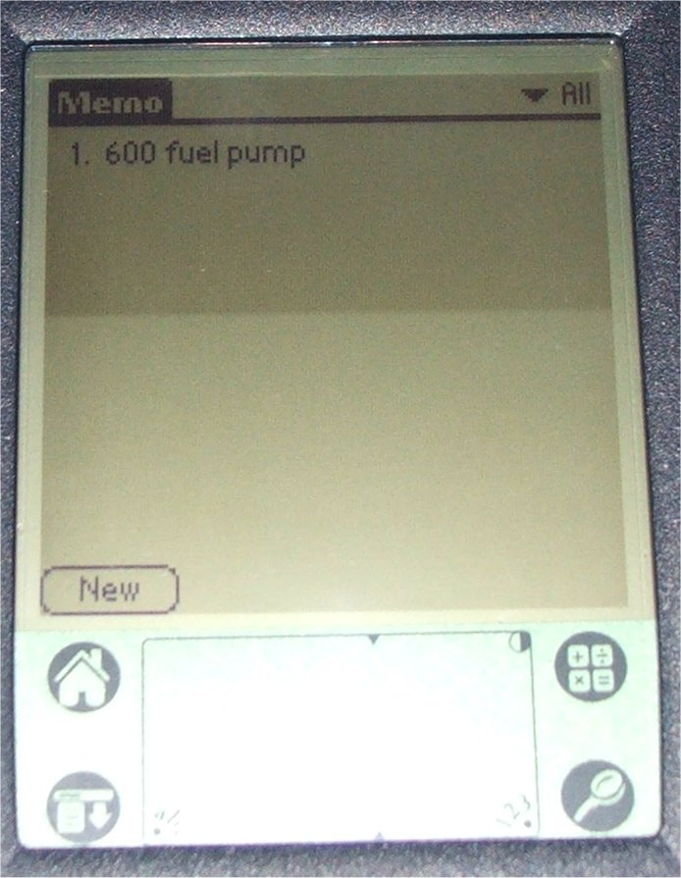

It returns you to the main memo screen with a list of all added memos.

This data must be manually entered into QuickBooks.

# Definitions of terms:

The following terms are used throughout this documentation and may not be clear in their usage.

Customer – All buses are customers. This is to provide “per bus” tracking of part usage.

Item – Item is used liberally throughout these documents and is most commonly an inventory item but can also be database data “items” such as customers, invoices, purchase orders. If any clarifications are needed email [info@laymanspc.com](mailto:info@laymanspc.com).

Pick – The act of pulling items out of inventory for use on a particular invoice. (A pending invoice must be created in Quickbooks to have items picked from inventory)

Receive – The act of adding purchased items to inventory. (A pending purchase order must be created in Quickbooks in order to receive items into inventory)