Lifecycle of MLTA Inventory

A purchase order is created in QuickBooks, if no MLTA item number is assigned, one must be assigned at that time. (See adding new items and item numbering.)
A transfer to the MobileInventory database is required to import new items and purchase orders from QuickBooks. (See transferring data from QuickBooks with MobileInventory.)
When items arrive, new labels should be printed, each item should get its own label. (See printing labels for items.)
The P.O. should be manually received in QuickBooks, and a transfer to MobileInventory performed, and items placed on the shelves according to their locations on the labels.
As garage personnel uses items off the shelves they will create “memos” by first scanning the bus, then scanning the items they use, and finally saving the memo. (See creating Memos with MemoPad.)
When accounting imports items from the PDA, they will print the memos and create invoices for each bus. (See Pulling Inventory for use on Buses and Adding Pulled Inventory to the Database..)

PDA Walkthrough
There is a pointer or “stylus” located in the top right corner of the PDA. It is used to tap/touch different items on the PDA screen to interact with the device.
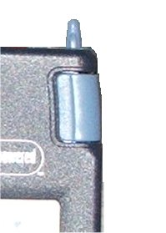

The blue button located at the bottom left edge is to power the PDA on. The following image is of the main screen of the PDA, the power button is visible in the lower left corner.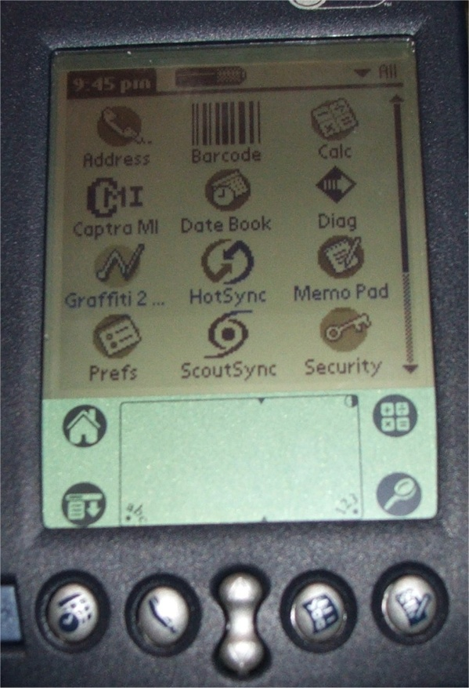
Make note of the picture of the house at the left side of the lower panel of the screen, at any time you get lost you can touch it with the pointer and return to the main screen.

At the top of the PDA there are two blue buttons on both the right and left edges, these are shown in the following image and used to activate the bar code scanner function. NOTE: While in Captra, please do not scan items not already in the QuickBooks database and assigned MLTA part numbers. You may scan other bar codes while in Memo Pad (to enter manufacturer’s part numbers, etc; mentioned later)
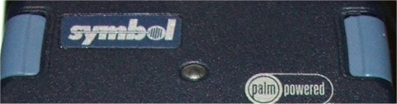

When text or numbers need to be entered, use the pointer to touch below the screen near the bottom where you see “abc” or “123” to open the onscreen keyboards. The screens are shown below.
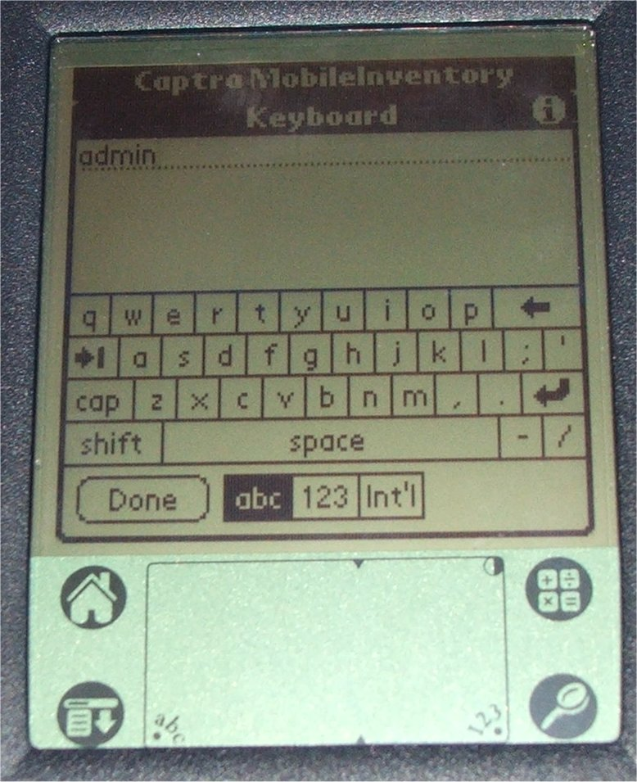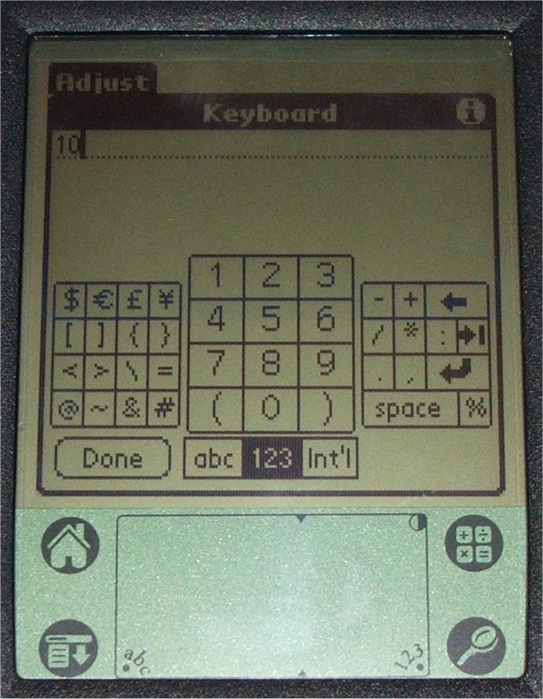
Make note on the right of both screens, there are two arrows pointing left, the top one that points straight left is backspace (to correct typos) and the one that points down and to the left is the “line return” or “enter”.
The rectangle at the bottom can be use for handwriting recognition, the left section for letters, the right for numbers.

The button used to perform the “hot sync” procedure is located on the base unit of the PDA and the PDA must be securely seated in the base to perform a hot sync. The button on your unit is broken; I advise using the stylus for the PDA to gently press the button. Shown below, you must press directly in the center (on the white part).
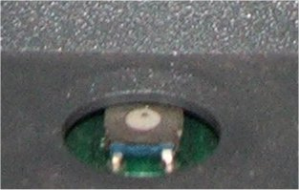

Adding New Items and Item Numbering
All new inventory items must be added to QuickBooks (in the item list) and then a data transfer in MobileInventory to copy data from QuickBooks to MobileInventory. The Inventory Items shall be assigned a unique number for use in the MLTA database. It will consist of an eight digit number. The first three digits will indicate a classification of the item, the following are the category assignments:
- 100—Hardware (this consists of general screws and miscellaneous hardware items and should
only be counted per container unless needs arise for more precise monitoring)
- 200—Chassis Electrical (this can include interior or exterior lighting , fuses, relays, radios and
GPS)
- 300—Chassis Mechanical Components (brakes, suspension, exhaust components, doors, windows,
- body panels, light housings)
- 400—Engine Electrical (sensors, switches, wiring, connectors, ignition components, alternators,
starters)
- 500—Engine Mechanical Components (items such as, turbo kits, A/C pumps, Water pumps)
- 600—Fuel System Components
- 700—Chemicals (i.e. Brake Parts Cleaner, antifreeze/coolant, WD-40, Car Wash Solution)
- 999—Category unknown or not listed
The final five digits of the item number will be added by the personnel who enter the data into QuickBooks and should be added in a sequential order starting 10000, 10001, 10002, 10003, etc.
Items that are “paired” items can be listed as “sub-categories” to what is shown above. As an example, headlight bulbs may be 20110035, the headlight high beam switch could be 20210035, the headlight on/off switch could be 20310035, or a special “specific-use” bolt could be 10110049 could have a corresponding nut 10210049. Fuel System Components category could be divided with 600—649 numbers being reserved for diesel parts and 650— 699 being used for gasoline parts. This truly should only be used in specific circumstances and will require either the garage personnel or a dedicated storeroom clerk to group the items.
Once adding extra vendors for identical parts (to have different price points set) the numbers will have “.01”, “.02”, etc. added to the end. i.e. 40010025 is an oxygen sensor from the primary vendor, 40010025.01 would be the same part from a secondary distributor).

Adjusting Item Quantities (Matching database to physical count)

This procedure is used to do a physical inventory count in the store room and adjust QuickBooks to match.
Start Captra MI, choose adjust.
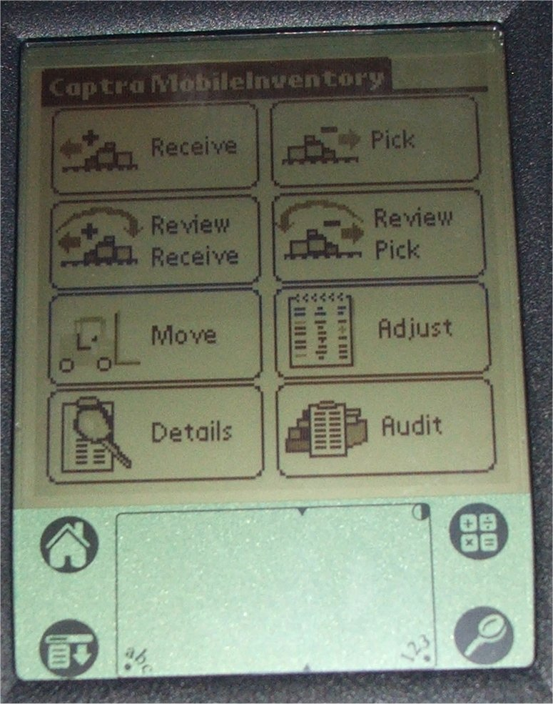
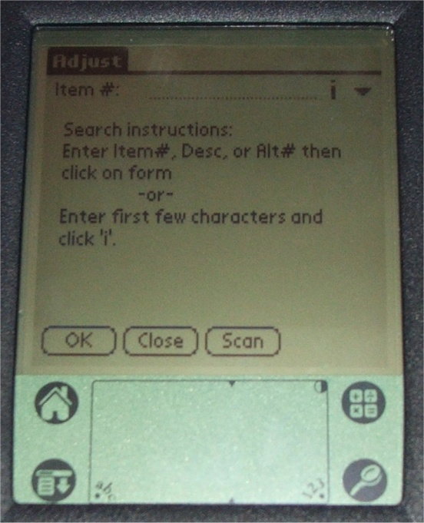
Here you will either touch the screen where it says “Scan” to activate the scanner for 5 seconds or press one of the blue scan buttons at the top corners and scan the item’s bar code. Please be sure you are scanning a current MLTA bar code. The following screen will appear.
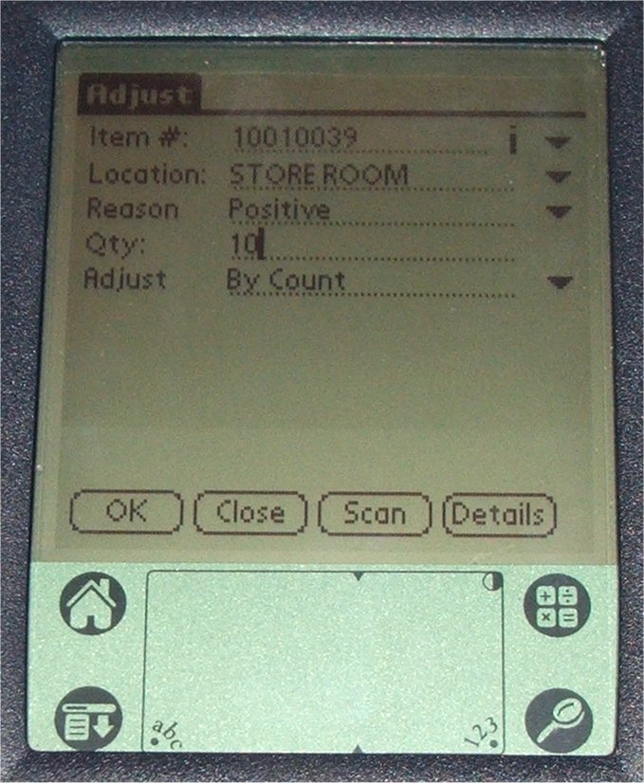
The breakdown of this screen is as follows:
The Item # field will be filled in by the number of the item scanned. You can touch the “down arrow” to the right of the Item # to change the view of this field to show the description of the item rather than the item number.
The Location field can be altered to match only locations added in the software. To make a selection from available choices, touch the “down arrow” at the right side of this field and select from the list.
The Reason can be listed as Positive (used when inventory database indicates less than is on the shelf, Positive will be used), Negative ( when inventory database indicates there are more than is physically on the shelf, Negative will be used), Lost (When an item is temporarily removed from the store room then misplaced, it must be removed from inventory but not be added to a memo for a truck. An adjustment should be done to reflect these items), Found (when a previously lost item is found, this is used to add it back into inventory), Return (When used parts are still part of a memo that has not yet been invoiced, they can simply be removed from the memo and returned to the shelf. Only when parts were removed, memo created and invoiced by accounting should “return” be used and a memo should be created indicating the bus it was intended for and that the part was a return and not a pull.), Breakage (in getting an item from stock and a broken part is noticed on the shelf, Breakage should be used). Use the “down arrow” at the right of that field to select whatever is appropriate.
The Qty field should reflect the number you personally count. You can either write the number in the right portion of the handwriting recognition screen, or touch the “123” at the bottom and activate the onscreen number pad to enter the quantity.
The Adjust field works in conjunction with the Qty field to maintain proper item counts in the database. There are the following choices available for this field: By Count and By Difference. By Count is used when all of an item has been counted and you are entering the exact quantity on hand (already in inventory and not already in inventory). By Difference is used when you are only counting a specific number of an item that’s not already in inventory (i.e. you find a box of 15 of an item and determine it is not part of the current inventory count and just want to add them to existing inventory, you would perform an “adjust” of “15” “found” by “difference” and it will add 15 to whatever the existing count is).
Once all the fields are completed, you can touch the “OK” button on the lower left portion of the screen. It will make the change in the PDA database and clear the form for the next item. When completed with adjustments of all items, touch the “Close” button at the bottom of the screen. (NOTE: when completing inventory adjustments please only choose “Close” from a cleared screen after “OK” has been selected and the item adjusted.)

Import quantity adjustments from the PDA into QuickBooks.

First insert the PDA into the cradle and start both, QuickBooks and Captra. In Captra, choose “Mobility” on the left at the bottom, and then choose “PDA to PC” from the right portion of the screen. You will see the following screens.
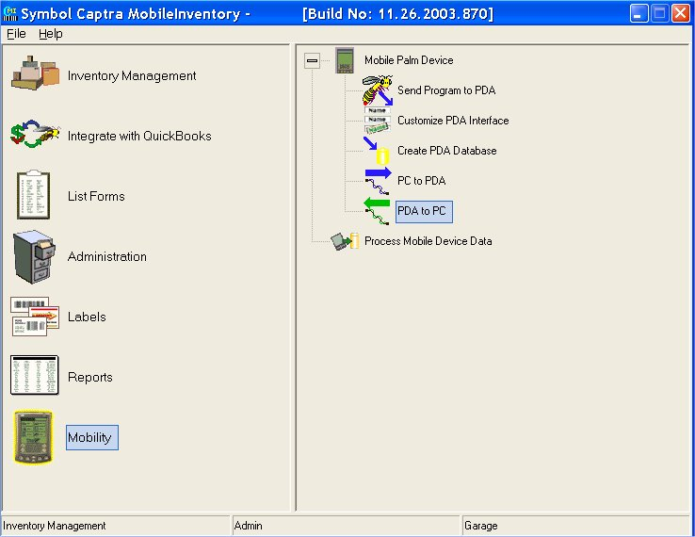
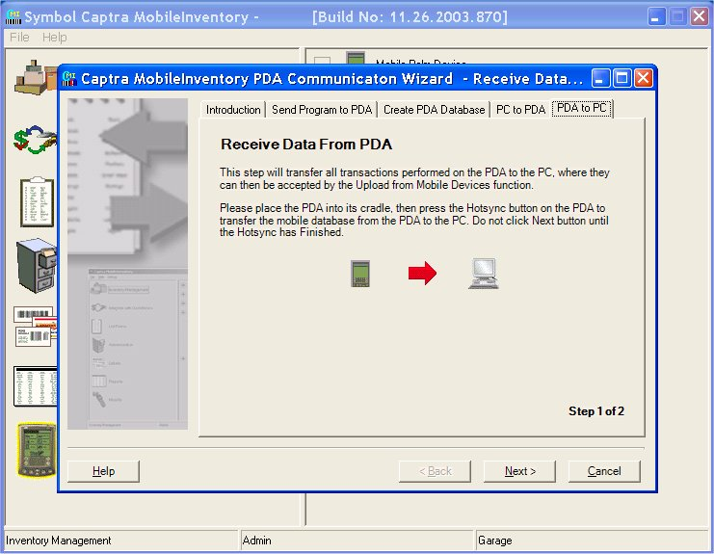
At this screen you will press the “Hot Sync” button on the PDA Cradle. (Shown below)
The system will begin the procedure of receiving the PDA quantity adjustments into the Captra MI software in the PC. After it completes the transfer, it will bring up the following screen, press “Finish”.
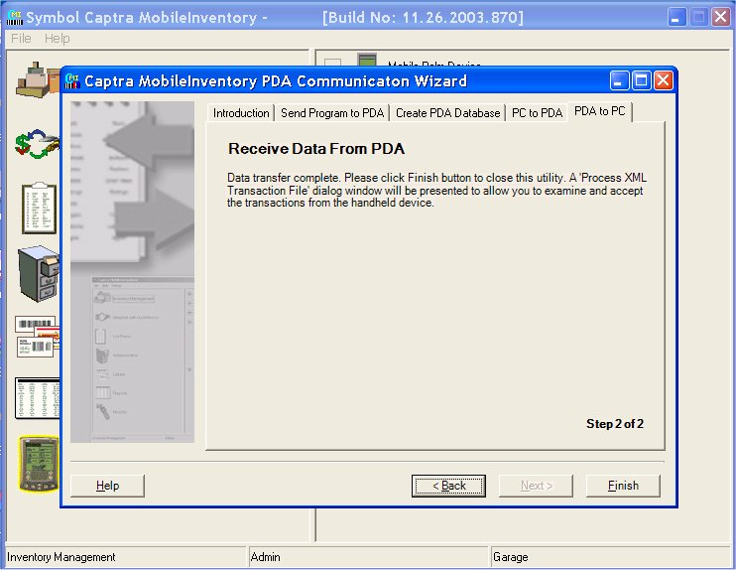
After pressing “Finish” (above) Captra will display the screen to upload changes into the Captra MI database. (Shown below)
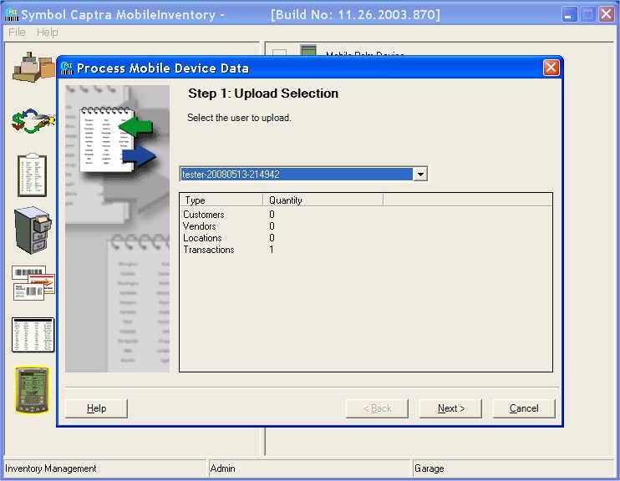
First you will be presented with the screen above. You will have a list of profiles containing dated changes in the selection drop down box. In most cases there should only be one to choose from as only changes that have not been properly imported will show up in this list. After selecting the set of changes you wish to import in the screen above, click “Next” to see the following screen.
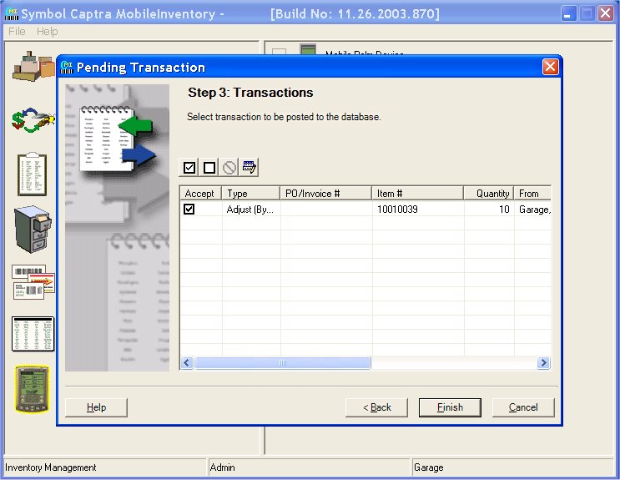
At this screen (shown above) you will have a list of changes that were made with the PDA to inventory items. Select them for import into the database by placing a check in the box to the left of each item. If there is an error with any item that prevents it from being imported it will be indicated by a red circle with a line through it. The four buttons just above the list can be used to get the details of the failure and make edits to the transactions so they can be imported. Once you have all transactions ready for import, press the “Finish” button at the bottom.

Balancing Captra and QuickBooks item counts.

** NOTE ** For this part of the procedure you must have QuickBooks in “Single user mode”.
Starting with Captra MI open, select “integrate with QuickBooks” on the left, and then “Compare Inventories” on the right. (As shown below)
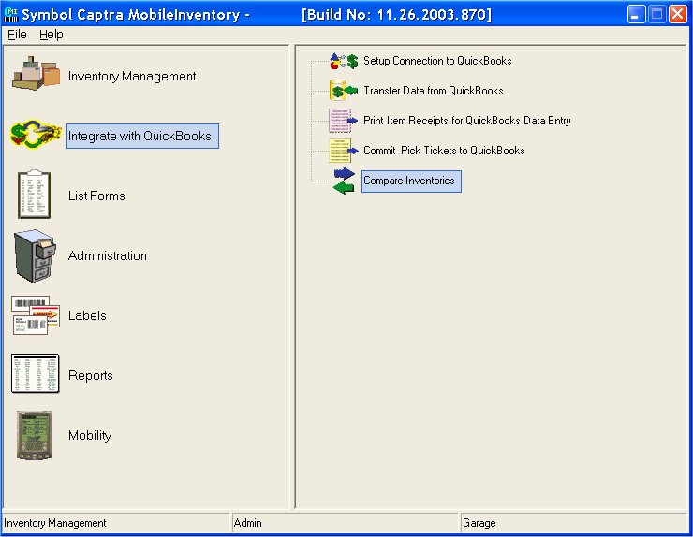
Step 1, shown below, you will simply click “Next”.
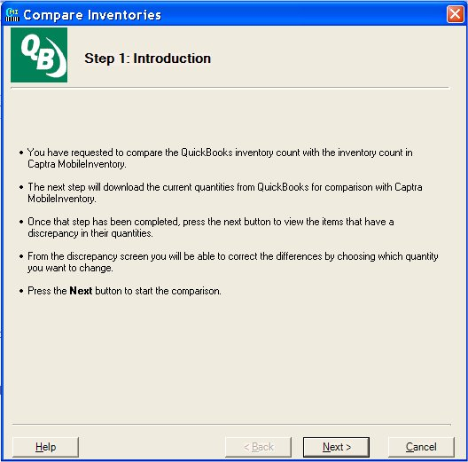
Pressing next will display the following screen. Here Captra will make connection to the QuickBooks database and analyze the data. (Shown below)
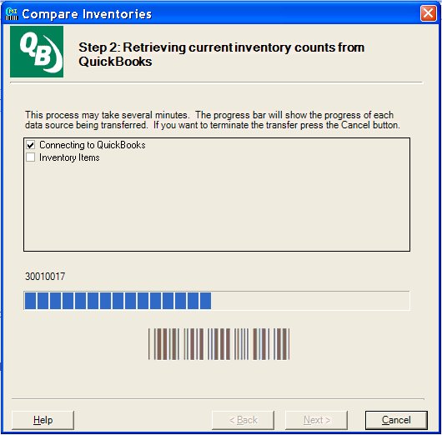
Once Captra is completed analyzing the QuickBooks inventory it will display a list of items that contain differing quantities. (Shown below)
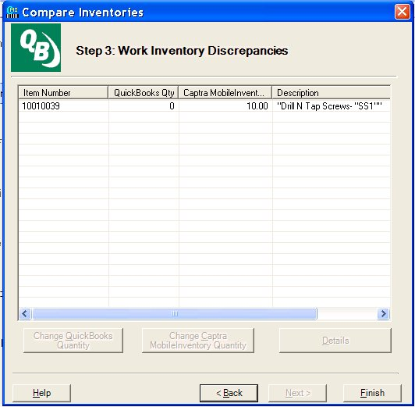
In the screen above you select the item or items that are different and the buttons at the bottom will become available for selection. (Shown below)
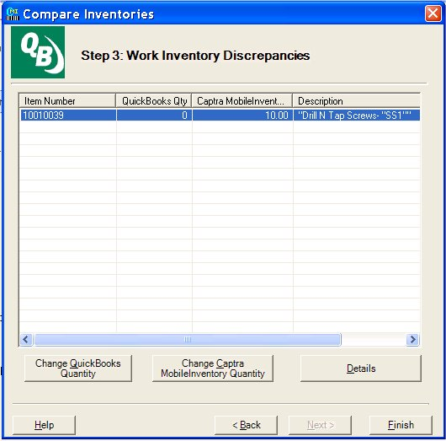
Selecting each item that needs adjusted; choose the “Change QuickBooks Quantity” button on the left to change the quantity in QuickBooks to match MobileInventory. This will change the QuickBooks inventory to match the current Captra database and should be used when a physical inventory count of the storeroom has occurred. “Change Captra MobileInventory Quantity” should be used to make the MI quantities match the QuickBooks database. This is done anytime any quantity adjustments have been performed directly in QuickBooks such as receiving Purchase Orders or Invoicing items to a vehicle.

Pulling Inventory for use on Buses
An overview of the steps involved in pulling parts from inventory for use on buses is as follows:
- Start Memo Pad on the PDA.
- Examine current memos to find the bus needing parts. If one exists, open it, skip to step 5.
- If no current memos exist for that bus, create a new memo.
- In creating a new memo, you can either use the barcode scanner to scan the vehicle identification barcode on the bus, or enter the word “bus” and the number of the bus to the first line. (the first line of the memos MUST be the bus number so memos are properly titled)
- On the next available line, use the code scanner function to scan in the part to be used. (Be sure to scan only the MLTA barcode tag and not a manufacturers or shipping tag.)
- On tasks that require more than one of an item, use the next line type the letter “Q” and the quantity to be removed from inventory.
- Go back to step 5 and repeat as many times as is needed to include all parts to be used on that bus. Once all parts for that bus have been added to the memo, press DONE on the PDA screen to save those items.

The above overview is described in more detail below.
- From the main screen on the PDA, tap the Memo Pad icon.

- When Memo Pad open, you be presented with a list of all current memos (as shown below). Examine the list for a memo on the current bus. If one exists, tap it with the PDA pointer/stylus to open it for additions and skip to step 5.
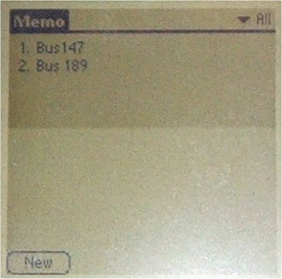
- If no existing memo exists for the current bus, create a new memo by tapping “New” at the bottom left corner of the screen. (shown above)
- In creating a new memo, the first line MUST be the bus number so memos are properly titled. You can activate the barcode scanner and scan the bus number in from the barcodes located on each vehicle, or manually enter the word “bus” and the number of the bus to the first line. (as shown below)

- On the next available line, use the code scanner function to scan in the part to be used. (Be sure to scan only the MLTA barcode tag and not a manufacturers or shipping tag.)

- On the next line type the letter “Q” and the quantity to be removed from inventory (only required when more than one of an item is used).

- Go back to step 5 and repeat as many times as is needed to include all parts to be used on that bus. Once all parts for that bus have been added to the memo, press DONE on the PDA screen to save those items.

- Deliver the PDA to the office for data import.

Adding pulled inventory to the database in QuickBooks.

Overview:
- Perform a PDA HotSync to the PC and open Palm Desktop.
- Choose Memo from the left side of the screen. (Shown below)

- Right click the list of memos and choose “Select All” to select all active memos for printing.

- Print items for QuickBooks entry. (Print button shown below) Within QuickBooks using the bus as a customer, all items should be invoiced per bus.

- Delete all memos when complete by right clicking the highlighted list and choosing delete (Be sure the option to “Archive Deleted Item(s) at next HotSync operation” is not checked).

- Perform a PDA HotSync to remove inactive memos.

