# Adjusting Item Quantities (Matching database to physical count)

This procedure is used to do a physical inventory count in the store room and adjust QuickBooks to match.

Start Captra MI, choose adjust.

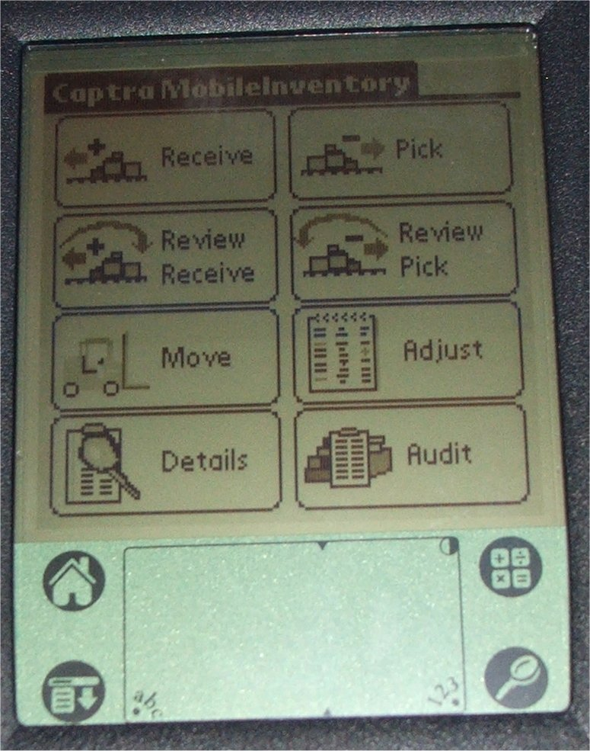

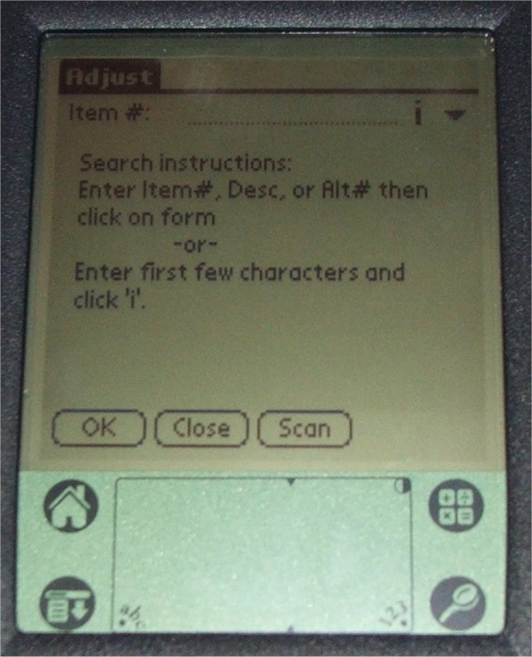

Here you will either touch the screen where it says “Scan” to activate the scanner for 5 seconds or press one of the blue scan buttons at the top corners and scan the item’s bar code. Please be sure you are scanning a current MLTA bar code. The following screen will appear.

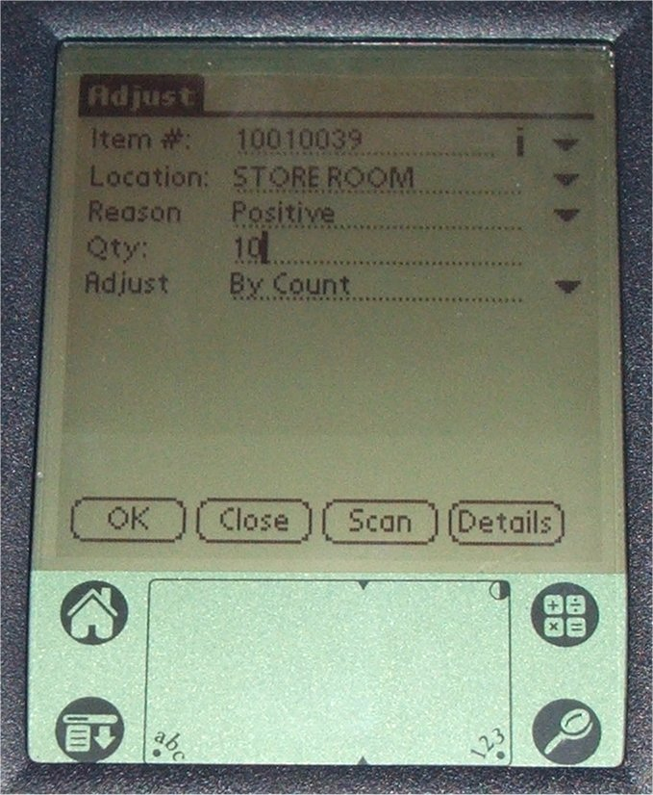

The breakdown of this screen is as follows:

The Item # field will be filled in by the number of the item scanned. You can touch the “down arrow” to the right of the Item # to change the view of this field to show the description of the item rather than the item number.

The Location field can be altered to match only locations added in the software. All shelf locations should be listed. To choose, touch the “down arrow” at the right side of this field and select from the list.

The Reason can be listed as Positive (used in performing physical inventory count; when inventory database indicates less than is on the shelf, Positive will be used), Negative (used in performing physical inventory count; when inventory database indicates there are more than is physically on the shelf, Negative will be used), Lost (an item is temporarily removed from the store room then misplaced, it must be removed from inventory), Found (when a previously lost item is found, this is used to add it back into inventory), Return (when an item is pulled from inventory and not used, Return should be chosen), or Breakage (in getting an item from stock and a broken part is noticed on the shelf, Breakage should be used). Use the “down arrow” at the right of that field to select whatever is appropriate.

The Qty field should reflect the number you personally count. Touch the “123” at the bottom and activate the onscreen number pad to enter the quantity.

The Adjust field works in conjunction with the Qty field to maintain proper item counts in the database. There are the following choices available for this field: By Count and By Difference. By Count is used when all of an item has been counted and you are entering the exact quantity on hand (already in inventory and not already in inventory). By Difference is used when you are only counting a specific number of an item that’s not already in inventory (i.e. you find a box of 15 of an item shoved under a bench and just want to add them to existing inventory).

Once all the fields are completed, you can touch the “OK” button on the lower left portion of the screen. It will make the change in the PDA database and clear the form for the next item. When completed with adjustments of all items, touch the “Close” button at the bottom of the screen. (NOTE: when completing inventory adjustments please only choose “Close” from a cleared screen after “OK” has been selected and the item adjusted.)

# Import quantity adjustments from the PDA into QuickBooks.

First insert the PDA into the cradle and start both, QuickBooks and Captra. In Captra, choose “Mobility” on the left at the bottom, and then choose “PDA to PC” from the right portion of the screen. You will see the following screens.

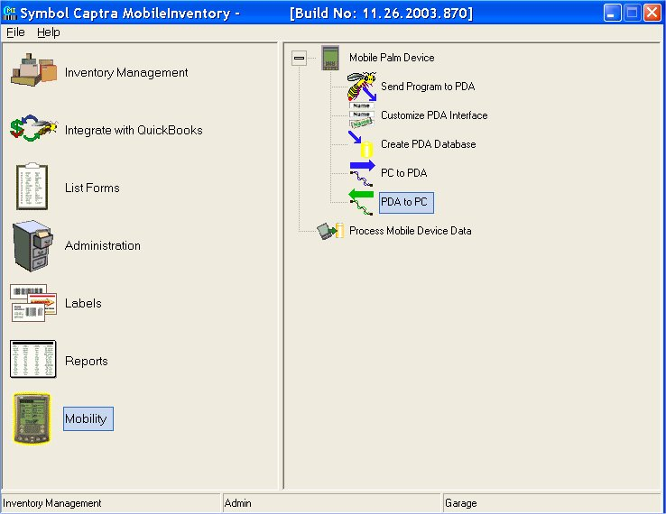

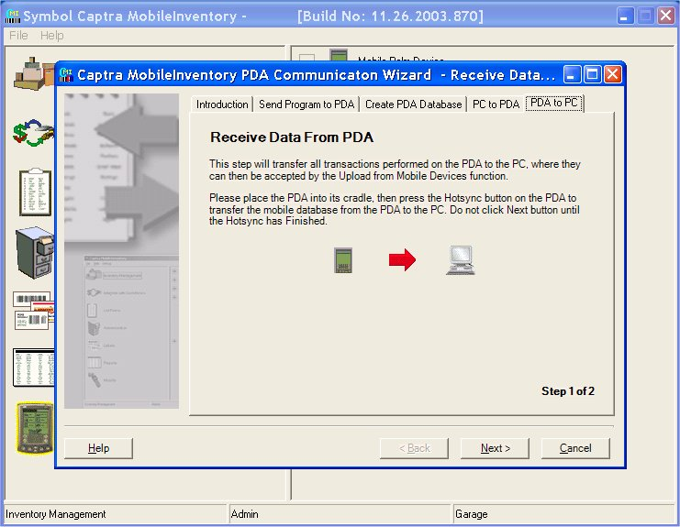

At this screen you will press the “Hot Sync” button on the PDA Cradle. (Shown below)

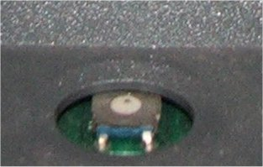

The system will begin the procedure of receiving the PDA quantity adjustments into the Captra MI software in the PC. After it completes the transfer, it will bring up the following screen, press “Finish”.

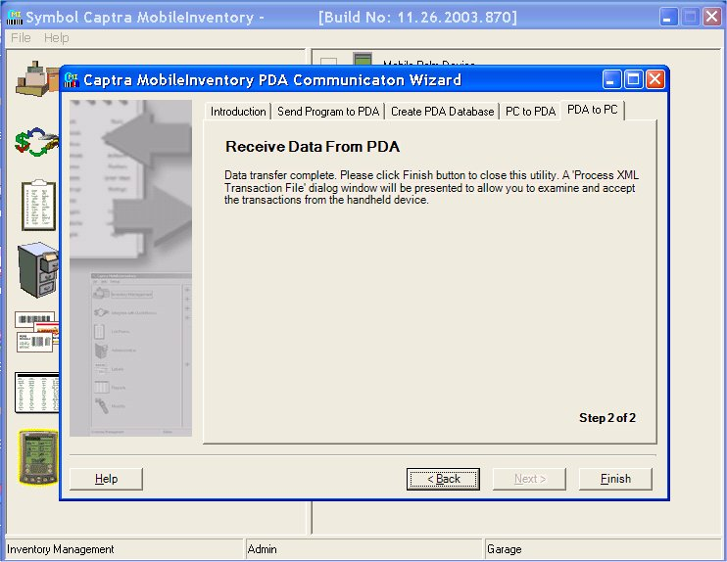

After pressing “Finish” (above) Captra will display the screen to upload changes into the Captra MI database. (Shown below)

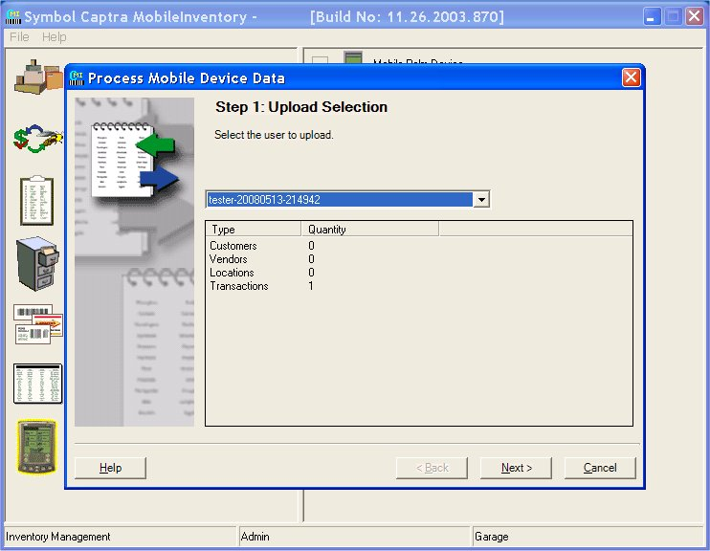

First you will be presented with the screen above. You will have a list of profiles containing dated changes in the selection drop down box. In most cases there should only be one to choose from as only changes that have not been properly imported will show up in this list. After selecting the set of changes you wish to import in the screen above, click “Next” to see the following screen.

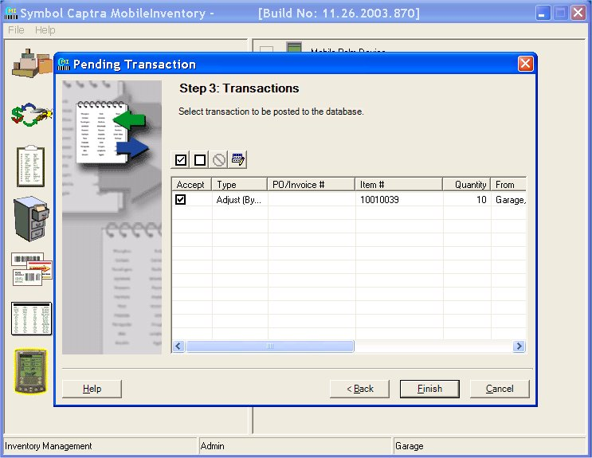

At this screen (shown above) you will have a list of changes that were made with the PDA to inventory items. Select them for import into the database by placing a check in the box to the left of each item. If there is an error with any item that prevents it from being imported it will be indicated by a red circle with a line through it. The four buttons just above the list can be used to get the details of the failure and make edits to the transactions so they can be imported. Once you have all transactions ready for import, press the “Finish” button at the bottom.

# Balancing Captra and QuickBooks item counts.

** NOTE ** For this part of the procedure you must have QuickBooks in “Single user mode”.

Starting in Captra MI, select “integrate with QuickBooks” on the left, and then “Compare Inventories” on the right. (As shown below)

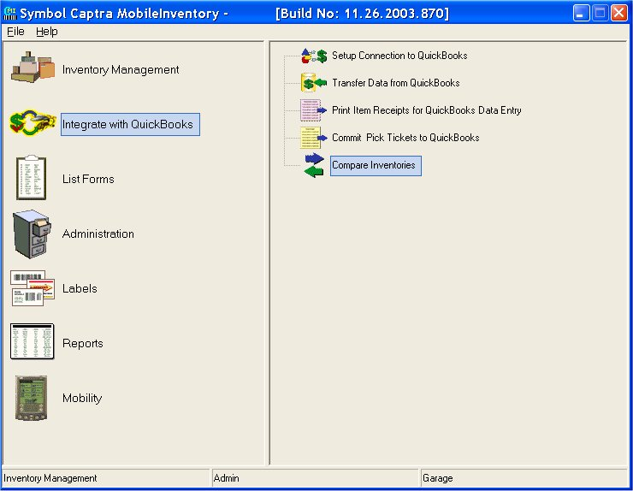

Step 1, shown below, you will simply click “Next”.

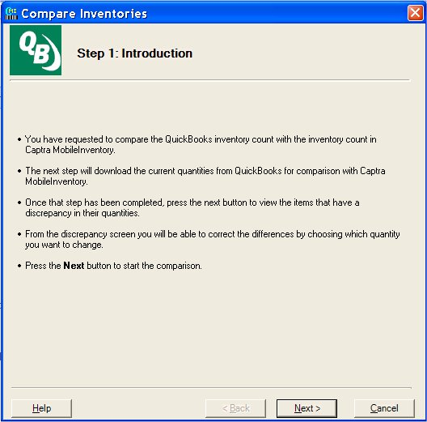

Pressing next will display the following screen. Here Captra will make connection to the QuickBooks database and analyze the data. (Shown below)

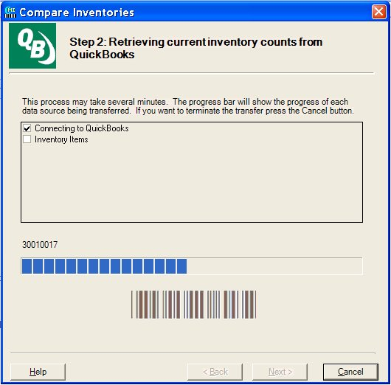

Once Captra is completed analyzing the QuickBooks inventory it will display a list of items that contain differing quantities. (Shown below)

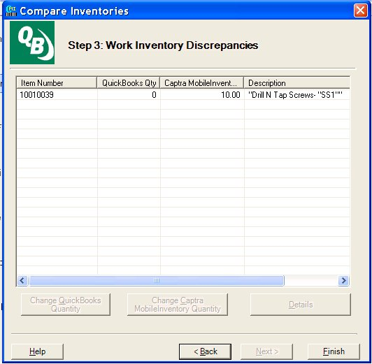

In the screen above you select the item or items that are different and the buttons at the bottom will become available for selection. (Shown below)

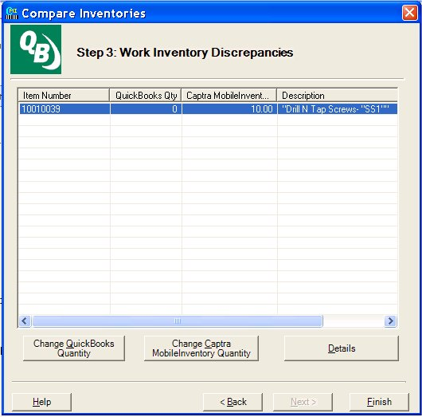

Selecting each item that needs adjusted; choose the “Change QuickBooks Quantity” button on the left. This will change the Quickbooks inventory to match the current Captra database.