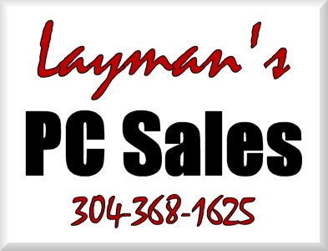 | INVOICE
Putting things into “Layman’s Terms” to make your PC less of a “Personal Confuser”. |  |  |  | Status: Not Paid  Date: 1/29/2009  INVOICE # 1945
TO |  | Sheldon Dawkins  CashLand Pawn  Morgantown & Clarksburg  (304) 292-3970 | SHIP TO | Sheldon Dawkins  CashLand Pawn  (304) 292-3970

Salesperson | Job | Shipping Method | Shipping Terms | Delivery Date | Payment Terms | Due Date
 |  |  |  |  | Due | 1/29/2009

Name | Description | Qty. | Unit Price | Discount | Line Total
# 10 10 Remote Service | *CLARKSBURG* - Repaired Clarksburg backup routine due to store location being changed into a "restore" folder located within the "xpawndata" folder. Reset backup to store entire "xpawndata" folder and all files and subfolders. | 1 | $25.00 |  | $25.00 | T
Total Discount: |  |  |  | $0.00
Subtotal: |  |  |  |  | $25.00
Sales Tax: |  |  |  |  | $1.50
Total: |  |  |  |  | $26.50
Payments: |  |  |  |  | $0.00
Balance Due: |  |  |  |  | $26.50
Thank you for your business!
Make all checks payable to Joe Layman

Route 3 Box 44
Fairmont, WV 26554-9412
Phone 304-368-1625 Fax 304-368-1625 info@laymanspc.com

