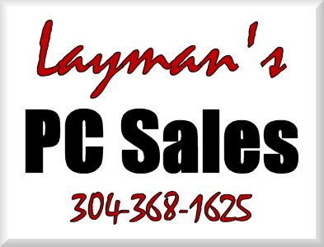 | INVOICE
Putting things into “Layman’s Terms” to make your PC less of a “Personal Confuser”. |  |  |  | Status: Not Paid  Date: 9/25/2008  INVOICE # 1691
TO |  | Sheldon Dawkins  CashLand Pawn  Morgantown & Clarksburg  (304) 626-3330 | SHIP TO | Sheldon Dawkins  CashLand Pawn  (304) 626-3330

Salesperson | Job | Shipping Method | Shipping Terms | Delivery Date | Payment Terms | Due Date
 |  |  |  |  | Due | 9/25/2008

Name | Description | Qty. | Unit Price | Discount | Line Total
# 3 Onsite Service | Time spent moving/adding cameras. 9/25 4:30P to 6:30P -- 10/8 3:30P to 4:30P -- 10/17 11:30A to 12:30P | 2.5 | $65.00 |  | $162.50 | T
Total Discount: |  |  |  | $0.00
Subtotal: |  |  |  |  | $162.50
Sales Tax: |  |  |  |  | $9.75
Total: |  |  |  |  | $172.25
Payments: |  |  |  |  | $0.00
Balance Due: |  |  |  |  | $172.25
Thank you for your business!
Make all checks payable to Joe Layman

Route 3 Box 44
Fairmont, WV 26554-9412
Phone 304-368-1625 Fax 304-368-1625 info@laymanspc.com

