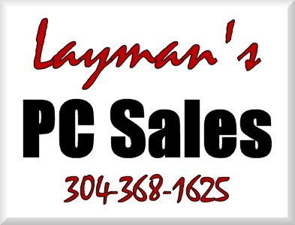 | INVOICE
Putting things into “Layman’s Terms” to make your PC less of a “Personal Confuser”. |  |  |  | Status: Not Paid  Date: 9/22/2008  INVOICE # 1687
TO |  | Sheldon Dawkins  CashLand Pawn  Morgantown & Clarksburg  (304) 626-3330 | SHIP TO | Sheldon Dawkins  CashLand Pawn  (304) 626-3330

Salesperson | Job | Shipping Method | Shipping Terms | Delivery Date | Payment Terms | Due Date
J.P. Layman |  | Service Delivery | Service Delivery | 9/24/2008 | Due | 9/24/2008

Name | Description | Qty. | Unit Price | Discount | Line Total
# 3 Onsite Service | 9/22 Connected and tested zebra label printer to main workstation, setup for 4x6 shipping labels - determined error message on 2nd workstation requires contacting xpawn.uk, have emailed them on the issue and will report back - setup webcam for customer snapshots on 2nd workstation - 9/22-9/23 reallocated drive space to allow digivue to use newest/larger of the drives and vivotek to use the older/smaller of the two drives - 9/23 replaced two capacitors in 37" TV. | 4 | $65.00 |  | $260.00 | T
Total Discount: |  |  |  | $0.00
Subtotal: |  |  |  |  | $260.00
Sales Tax: |  |  |  |  | $15.60
Total: |  |  |  |  | $275.60
Payments: |  |  |  |  | $0.00
Balance Due: |  |  |  |  | $275.60
Thank you for your business!
Make all checks payable to Joe Layman

Route 3 Box 44
Fairmont, WV 26554-9412
Phone 304-368-1625 Fax 304-368-1625 info@laymanspc.com

