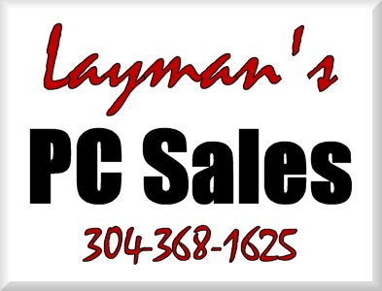 | INVOICE
Putting things into “Layman’s Terms” to make your PC less of a “Personal Confuser”. |  |  |  | Status: Not Paid  Date: 9/22/2008  INVOICE # 1684
TO |  | Sheldon Dawkins  CashLand Pawn  Morgantown & Clarksburg  (304) 626-3330 | SHIP TO | Sheldon Dawkins  CashLand Pawn  (304) 626-3330

Salesperson | Job | Shipping Method | Shipping Terms | Delivery Date | Payment Terms | Due Date
J.P. Layman |  |  | Service Delivery | 9/22/2008 | Due | 9/22/2008

Name | Description | Qty. | Unit Price | Discount | Line Total
# 3 Onsite Service | corrected recording balance between vivotek and digivue systems, inspected workstation2 repawn issue and will consult xpawn.uk, installed label printer | 1.5 | $65.00 | 10% | $87.75 | T
Total Discount: |  |  |  | $9.75
Subtotal: |  |  |  |  | $87.75
Sales Tax: |  |  |  |  | $5.27
Total: |  |  |  |  | $93.02
Payments: |  |  |  |  | $0.00
Balance Due: |  |  |  |  | $93.02
Thank you for your business!
Make all checks payable to Joe Layman

Route 3 Box 44
Fairmont, WV 26554-9412
Phone 304-368-1625 Fax 304-368-1625 info@laymanspc.com

